Investigating the Alignment of the English for Specific Purposes Course Syllabus with The Needs of Computer Science Students.

**Case of Master 1 Computer Science Students at Batna 2 University**

# A picture containing text, font, design, logo Description automatically generatedPAGE

Chihab Eddine. MAHDJOUB and Oussama Ayoub. ABDENNOURI

University of Batna 2, Department of English Language and Literature

In Partial Fulfillment for the Requirement of Master’s degree in

Linguistics and Applied Languages

Supervisor*: Dr. Tahar GOLEA*

*June 2023*

# Authors Note

**Dedications and Acknowledgments**

We would like to dedicate this work to our friends and family, who have supported us throughout this journey. We would also like to thank our supervisor, Dr. Tahar Golea, for his guidance and support. His expertise and patience have been invaluable to us.

We would also like to thank the following people for their contributions to this work:

* Our colleagues and teachers at the Department of English Language and Literature who provided helpful insight, feedback, and support.
* The members of the research community, who have shared their knowledge and expertise with us.
* The participants in our studies, who have shared their time and insights with us.

Finally, we would like to thank each other for our hard work and dedication. This work would not have been possible without our collaboration.

Thank you all!

**Contact Information**

If you have any questions about this document, please contact us at:

*Chihab eddine Mahdjoub:* [*mahdjoubchihab5@gmail.com*](mailto:mahdjoubchihab5@gmail.com)

*Oussama A. Abdennouri:* [*abdennouriayoub@gmail.com*](mailto:abdennouriayoub@gmail.com)

# List of Abbreviations

**APS**: Algerian Press Service

**CS**: Cryptographie et Sécurité

**EAP**: English for Academic Purposes

**EBP**: English for Business Purposes

**EFL**: English as a Foreign Language

**EGP**: English for General Purposes

**ELP**: English for Legal Purposes

**ELT**: English Language Teaching

**EMI**: English Medium Instruction

**EMP**: English for Medical Purposes

**EOP**: English for Occupational Purposes

**ESP**: English for Specific Purposes

**EST**: English for Science and Technology

**IAM**: Intelligence Artificielle et Multimédia

**ICT**: Information Communication Technology

**ISI**: Ingénierie des Systèmes Informatiques

**ISIDS**: Ingénierie des Systèmes d’Information Distribués etSécurité

**NA**: Needs Analysis

**RSD**: Réseaux et Systèmes Distribues

**SPSS**: Statistical Package for the Social Sciences

**UK**: United Kingdom

**US**: United States

# Table of Contents

**Cover Page** ............................................................................................................... I

**Dedications and Acknowledgments** .......................................................................... II

**List of Abbreviations** ............................................................................................. III

**Table of Contents** ................................................................................................... IV

**List of Tables** .......................................................................................................... VII

**List of Figures** ......................................................................................................... VIII

**Abstract** ................................................................................................................ X

**General Introduction** ........................................................................................... XI

1. **Literature Review** .................................................................................................. 1

**1.1 Introduction** ……………………………………………………………………1

**1.2 English as a Language of Educated Exchange** .......................... 2

**1.3 Overview of ESP** ................................................................................ 2

1.3.1 Definitions ......................................................................................................... 2

1.3.2 Characteristics ................................................................................................... 3

1.3.3 Origins and Development .................................................................................. 4

1.3.3.1 Origins: Historical Factors ......................................................... 4

1.3.3.2 Development and Trends in ESP ..................................................... 4

1.3.4 ESP vs EGP ....................................................................................................... 5

1.3.5 Branches of ESP ............................................................................................... 6

1.3.5.1 EAP and EOP ............................................................................... 6

ii. English for Science and Technology ......................................................... 6

**1.4 NA, Course Design, and Syllabus Design in ESP** ...... 8

**1.4.2 Needs Analysis** ................................................................................................. 8

1.4.2.1 Definition .......................................................................................... 8

1.4.2.2 Key Elements ....................................................................... 8

1.4.2.3 Instruments for NA ......................................................................... 8

1.4.1.4 Characteristics of successful ESP NAs. .........................................9

1.4.2.5 Procedures for NA ....................................................................... 9

1.4.2.6 Importance of NA .................................................................. 9

1. Impact of Needs Analysis on Course Effectiveness ..................... 9

2. Do CS Students Need Language? ............................................ 10

3. Necessity for a Comprehensive NA for CS Students in Algeria…11

**1.4.3 Course Design** .................................................................................................. 11

**1.4.4 Syllabus Design** ............................................................................................... 12

1.4.4.1 Definitions ............................................................................. 12

1.4.4.2 Principles and Rationale ............................................................... 12

1.4.4.3 Models and Types of ESP Syllabus .................................................. 13

1.4.4.4.4 Procedures for Designing Course Syllabus ...................................... 13

1.4.4.5 ESP Syllabus Designs in EST and Computer Science.......................... 14

**1.5 Conclusion** …………………………………………………………………….17

**2**. **Methodology and Data Analysis** ............................................................................ 18

2.1 Introduction ..................................................................................................... 18

2.2 Research Design ................................................................................................. 19

2.3 Sample Design ................................................................................................. 19

2.4 Data Collections Methods and Procedures ......................................................... 21

1. Questionnaire ........................................................................................... 21

2. Interview .................................................................................................... 22

3. Document Review ................................................................................... 23

2.4 Data Analysis Techniques ................................................................................ 23

2.5 Conclusion ...................................................................................................... 24

**3. Results and Discussion** ........................................................................ 24

**3.1 Introduction** ...................................................................................................... 24

**3.2 Needs Analysis Findings** .................................................................................. 25

3.2.1 Student Needs and Proficiency Levels .................................................... 25

1. Based on the Interview ........................................................... 25

2. Based on the Questionnaire ....................................................... 26

3.2.2 Motivation and Engagement ................................................................... 40

1. Based on the Interview ................................................................ 40

2. Based on the Questionnaire ........................................................ 40

**3.3 Course Syllabus Design Findings** ...................................................................... 44

3.3.1 Course Content and Structure .............................................................. 44

1. Based on the Interview ................................................................. 44

2. Based on the Syllabus Document ................................................. 45

3.3.2 Teaching Methods and Strategies ......................................................... 46

3.3.3 Students’ Perceptions of the Course ................................................... 46

**3.4 Challenges and Suggestions for Improvement Findings** .................................. 58

1. Based on the Interview .......................................................................... 58

2. Based on the Questionnaire .................................................................... 59

**3.5 Discussion** ....................................................................................................... 65

1. Key Factors Influencing the Effectiveness of the ESP Course.......... 65

2. The Alignment between the ESP course syllabus and Students Language Needs……………………………………………………………………..66

3. Summary…………………………………………………………………71

**4. Conclusion** .......................................................................................................... 73

**References** ......................................................................................................... 76

**Appendices** ......................................................................................................... 78

1. Teacher Interview ........................................................................................... 78

2. Student’ Questionnaire .................................................................................... 79

3. Student’ Questionnaire in Arabic ...................................................................... 86

4. Public Syllabus Document .............................................................................. 93

5. Alignments and misalignments table for discussion ............................................ 95

6. EST Syllabus design for EST table ......................................................................... 97

**Resume in Arabic** ......................................................................................................... 99

# List of Tables

**Table 1:** The distribution of Master 1 Computer Science students across specialties

**Table 2**: Discussion table for alignments and misalignments of the ESP course

**Table** **3**: Chandra Sekhar Rao’s (2017) Syllabus For EST

# List of Figures

**Figure 1: ELT tree, Hutchinson, and Waters (1987: 17)**

**Figure 2:** Characteristics of a syllabus (Ur, 1996, p. 177, mentioned in Basturkmen, 2006, p. 21)

**Figure 3**: Distribution of participants by specialty

**Figure 4:** students’ proficiency level in each skill

**Figure 5:** Students’ perceptions on the importance of English in Computer Science

**Figure** **6**: Students’ perceptions on their needs for English in their field.

**Figure** **7**: students current use of English

**Figure** **8**: Students perceptions on the language skills they need to improve most

**Figure** **9**: Students’ reported language difficulty

**Figure 10**: Students’ preferred testing.

**Figure 11:** Students attendance frequency

**Figure 12:** Students motivations for attendance

**Figure 13**: Students’ perceptions on the course’s alignments with their needs.

**Figure 14:** Students’ perceptions on the teaching methods and activities used most.

**Figure 15**: Students perceptions on the success of the teacher’s teaching methods/activities in improving their needed skills

**Figure 16:** Students perceived helpfulness of teacher’s use of ICT tools

**Figure 17**: Students’ perceptions on the relevance the passages and exercises in the course.

**Figure 18:** Students’ perceptions on the appropriateness of the passages and exercises in the course.

**Figure 19:** Students’ perceptions on the grades reflecting of their level

**Figure 20**: Students’ perceptions about the helpfulness of teacher’s feedback in improving their language performance.

**Figure 21**: Students’ perceptions on the allotted time’s sufficiency

**Figure 22**: Students’ preferences for allotted time extension

**Figure 23**: Students’ preferences for in-class or online courses

**Figure** **24**: Students perceptions on English as the instruction language in other Computer Science courses.

# Abstract

This research investigates the alignment between the English for Specific Purposes (ESP) course syllabus for Master 1 computer science students at Batna 2 University and their specific language needs and expectations. With English being the dominant language in scientific and technological fields, including Computer Science, having an effective ESP course is essential for students to develop the necessary language skills for academic and professional advancement. The study employs a mixed-methods approach, involving questionnaires, interview, and document review to identify students' needs, preferences, and attain a nuanced understanding of the ESP course Syllabus design. The research critically analyzes the current ESP syllabus, evaluates its alignment with students' needs, and highlights areas for potential improvement. Findings indicate that although the course possesses strengths, there are areas where it falls short in meeting students' needs due to the lack of a formal investigation of learner's language situation. The study proposes recommendations to enhance the effectiveness of the ESP course, including conducting comprehensive needs analysis, revising the syllabus in line with students' professional and academic language requirements, adapting teaching methods to accommodate major-specific needs, and investing in the learning environment and instructors' professional development. The suggested improvements aim to contribute to better academic and professional outcomes for students, inform curriculum design and pedagogical practices beyond Batna 2 University, and align with the broader national priorities of supporting technological innovation using an informed scientific analysis from an applied linguistic perspective.

Keywords: English for Specific Purposes (ESP), Needs, Course Syllabus, Language learning goals, Technological advancement

# General Introduction

English is the dominant language in scientific and technological fields, particularly in the domain of Computer Science. The vast majority of scientific publications, technical documentation, and conference presentations are written in English, making it necessary for individuals in this field to possess a strong command of the language. Furthermore, with the rapid and continuous technological developments in this field, it is crucial for both students and professionals to know English to be able to continually update their skills in order to stay competitive and not fall behind. In Algeria, supporting technological innovation is a priority for the current administration, and therefore, it is essential to have an effective English language education for Computer Science students and professionals to help further develop their research and practical skills.

**Statement of the Problem**:

English for Specific Purposes (ESP) courses are designed to cater to the language needs of specific groups of learners, such as those in the field of Computer Science. The Department of Computer Science at Batna 2 University offers an ESP course to Master 1 students. However, it is unclear whether the current ESP syllabus in the department of Computer Science aligns with the specific needs of students in that department. Feedback from the students suggest a potential gap in the quality of the English language education provided. The students expressed their dissatisfaction with the course offerings as they believed the course does not sufficiently meet their needs. This raises concerns about the effectiveness of the course in helping the students achieve their language learning goals in the context of computer science.

**Significance of the Study:**

Investigating the alignment between the needs of students and the ESP syllabus in the Department of Computer Science is significant for several reasons. Firstly, it can help ensure that students are equipped with the necessary language skills to excel in their careers. By addressing the specific language needs of Computer Science students and identifying areas where the ESP syllabus can be improved or updated, the research can lead to better academic and professional outcomes for the students and contribute to their overall growth and development in the field of Computer Science. In addition, the research findings can serve as a basis for making informed decisions regarding modifications to the ESP syllabus in the Department of Computer Science.

Furthermore, investigating the alignment between the ESP syllabus and the needs of students can contribute to the broader conversation on how best to teach language skills in the context of specific academic disciplines. By focusing on the field of Computer Science, this research can shed light on effective approaches and methodologies for teaching English for Specific Purposes (ESP) in similar domains. The findings can inform curriculum design and pedagogical practices, benefiting not only the students at Batna 2 University but also other institutions and researchers interested in ESP.

Lastly, this research is timely and relevant, given the fast-paced evolution of technology, the increasing demand for scientists and skilled professionals in the field of computer science, and the national prioritization of technological integration and innovation.

**Objectives of the study:**

1. To identify the specific language needs and expectations of Master 1 computer science students in the Department of Computer Science at Batna 2 University.

2. To critically analyze the ESP course syllabus design and its components for relevance and appropriateness.

3. To assess the alignment between the ESP course syllabus design and the identified language needs and expectations of the students.

**Research questions:**

1. What are the factors that influence the ESP Course success?
2. To what extent is the current ESP course aligned or misaligned with the needs and preferences of Master 1 Computer Science students?
3. What improvements or modifications can be made to the ESP course syllabus to better meet the language needs of Master 1 Computer Science students?

**Hypothesis**:

The dissatisfaction expressed by the Master 1 Computer Science students towards the ESP course could be attributed to a potential mismatch between the course offerings and their specific needs

**Methodology**:

Given the nature of this research, a mixed methods approach is employed, utilizing questionnaires, interview, and document review as data collection methods.

Questionnaires are utilized to gather quantitative data from the large population of Computer Science students. This method is efficient and allows for the collection of a substantial amount of data within a relatively short timeframe.

Syllabus document review and teacher’s interview are used to obtain in-depth knowledge about the ESP course. This would provide qualitative data that complements the quantitative data collected through the questionnaires. By combining quantitative and qualitative data, a comprehensive understanding of the effectiveness of the course syllabus design in meeting the needs of computer science students at Batna 2 University can be achieved.

The sample design for this study focuses on Master 1 Computer Science students at the Department of Computer Science, Batna 2 University. The population consists of five specialties: CS, IAM, ISI, RSD and ISIDS. To ensure representation of the population and the generalizability of the findings, a stratified sampling approach is employed, randomly selecting 20% of students from each specialty group. RSD students (176) are excluded from the study as they did not have an English class in the first semester. Consequently, the final sample size consists of 55 students, along with only one ESP teacher for the interview.

For data analysis, statistical software such as SPSS and Microsoft Excel are used to analyze the quantitative data, while thematic analysis will be used to analyze the qualitative data. The results of the data analysis are used to evaluate the ESP course offerings, identify the challenges and factors influencing the success or failure of the course, and make recommendations for improving the quality of ESP education in the department.

**Structure of the dissertation:**

This dissertation is divided into four chapters, excluding the introduction. The first chapter titled Literature Review deals with a critical analysis of the existing literature on the topic, which provides a theoretical framework for the study and demonstrates the need for the research. The second chapter titled Research Methodology Design provides a detailed explanation of the research design, including the research approach, data collection procedures, sampling strategy, and data analysis techniques. The third chapter titled Results and Discussion involves the presentation of the findings, as well as the interpretation of those findings, a comparison with the existing literature, and an explanation of the implications regarding the research questions and objectives. The fourth and last chapter titled Conclusion will be devoted to the summary of the main findings, limitations of the study, the implications of the study, and recommendations for future research.

# 

# Chapter 1: Literature Review

## Introduction:

This chapter offers a review of existing literature pertinent to our research aims and objectives, thereby setting a theoretical framework for the study. We delve into key thematic areas of interest that have the potential to illuminate our understanding of the specific language needs and expectations of Master 1 Computer Science students in the Department of Computer Science at Batna 2 University, the current ESP course syllabus, and the alignment between the two.

Firstly, we consider the role and dominance of English as the language of science. Understanding this position provides context for our exploration of English for Specific Purposes (ESP) in the Computer Science domain.

We then explore the definitions and characteristics of ESP, noting the nuanced ways it caters to specific disciplinary needs, as opposed to General English. This exploration is further expanded through the examination of the various branches of ESP, and an overview of its history and development.

We then turn our attention to Needs Analysis (NA), To better understand how ESP can be tailored to meet the specific needs of learners. A detailed review of the definition, key elements, instruments, characteristics of successful NAs, procedures, and importance of Needs Analysis in the context of ESP courses is conducted.

Finally, the focus shifts towards course and syllabus design, including an investigation into the definition, principles, rationale, and the different models and types of ESP syllabuses. Here, we examine previous studies on ESP syllabus design and implementation for Computer Science students, and relevant studies from English for Science and Technology (EST) domains, to shed light on best practices for designing the course syllabus.

This literature review aims to furnish a comprehensive theoretical understanding that can guide our exploration of the ESP needs of Master 1 Computer Science students at Batna 2 University and evaluate the current ESP course syllabus. By situating our study within the larger context of existing scholarship, we can better navigate the complexities of our research questions and, ultimately, make meaningful contributions to the field.

## 1.2. English as a Language of Educated Exchange:

The English language dominates scientific research. Its use as an international language of science is well documented, to the extent that it can be seen as a *Lingua Franca* for educated exchange. (Tardy, 2004). According to Van Weijen (2012), 80% of all articles currently in the SCOPUS database, which is the world’s largest database for peer-reviewed journals, are written entirely in English. (A journal published in a language other than English must at least have English abstracts to be eligible for inclusion in the SCOPUS database). In certain non-English speaking countries such as France, Spain and Germany, English has become so prevalent that academic papers in English now surpass those written in the countries’ own languages by a significant margin. The Netherlands presents an especially noteworthy case, with a staggering ratio of 40 English-language papers to every one publication in the Dutch language (Van Weijen, 2012).

Dearden (2014) explains that the use of English as the main language of instruction in non-English speaking countries is rapidly growing; this is especially true in higher education but also increasingly prevalent in primary and secondary schools. “There appears to be a fast-moving worldwide shift, in non-Anglophone countries, from English being Taught as a foreign language (EFL) to English Being the medium of instruction (EMI) for academic Subjects such as science, mathematics, geography and medicine.”

According to Huttner-Koros (2015) the dominance of the English language in scientific publications means that non-English articles may struggle to reach a wide audience, with all of the top 50 scientific journals being published in English and originating from the US or the UK. As a result, scientists who aim to produce globally recognized and influential work must publish in English, in order to gain international recognition and a high reputation.

In conclusion, the primacy of the English language in scientific research and international academic exchange has become well-established. Its use as the primary language of education worldwide is on the rise. Knowing English has become essential for scientists who want to gain international recognition and students who want to excel in their fields of study.

## 1.3. An Overview of ESP:

### 1.3.1 Definitions of ESP.

English for Specific Purposes (ESP) is a specialized approach to language learning that focuses on meeting the specific needs of learners within defined contexts, tasks, or vocations. According to Mackay and Mountford (1978, p. 4), ESP involves a restricted repertoire of words and expressions selected from the whole language to cover every requirement within a particular context. In this regard, they (1978, p. 2) add that ESP: “is generally used to refer to the teaching of English for a clearly utilitarian purpose, this purpose is usually defined with reference to some occupational requirements, (e.g.: for international telephone operators) … or vocational training programmes, (e.g.: for hotel and catering staff) …or some academic or professional study, (e.g.: engineering) …”

Similarly, Hutchinson and Waters (1987, p. 19) emphasize that ESP is an approach to language learning rather than a product, and that it has the learners’ needs at the center of the course. In their words: "ESP, then, is an approach to language teaching in which all decisions as to content and method are based on the learner's reason for learning". They add " ESP should properly be seen not as any particular language product but as an approach to language teaching which is directed by specific and apparent reasons for learning".

More recently, Tomlinson (2003, p. 307) defines ESP as “an umbrella term that refers to the teaching of English to students who are learning the language for a particular work or study-related reason”. ESP focuses on various academic or professional fields that require specialized English language skills, such as business, medicine, law, engineering, history, art, and other areas.

Harding (2009) views ESP as the practical implementation of English language teaching, emphasizing its application in a variety of work and study contexts. He notes that *“*ESP is the coal-face of International English: “it is its practical application. And it’s not just the coal-face: it’s the production line, the operating theatre, the reception desk, and the building site*”*.

Considering those definitions, we can say that ESP is a specialized approach to language learning that focuses on meeting the specific needs of learners in particular contexts. It is goal-directed, with all decisions about content and method based on the learners' reasons for learning. ESP is tailored to the language needs of learners in different fields of study and work. In this way, ESP provides a means of developing the language skills that are essential for success in specific academic or professional contexts.

### 1.3.2 Characteristics of ESP.

Dudley-Evans and St. John (1998, pp. 4-5), modified Strevens’ (1988) work and proposed the following characteristics of ESP:

Absolute Characteristics:

1. ESP is defined to meet specific needs of the learners.

2. ESP makes use of underlying methodology and activities of the discipline it serves.

3. ESP is centered on the language appropriate to these activities in terms of grammar, lexis, register, study skills, discourse, and genres.

Variable Characteristics:

1. ESP may be related to or designed for specific disciplines.

2. ESP may use, in specific teaching situations, a different methodology from that of General English.

3. ESP is likely to be designed for adult learners, either at a tertiary level institution or in a professional work situation. It could, however, be for learners at secondary school level.

4. ESP is generally designed for intermediate or advanced Students.

5. Most ESP courses assume some basic knowledge of the language system, but it can be used with beginners.

The absolute characteristics are consistent in all fields of ESP, while the variable characteristics can differ from one area to another.

### 1.3.3 Origins and Development.

#### 1.3.3.1 Origins.

Hutchinson and Waters (1987, pp. 6-17) explain how ESP emerged as a response to various historical factors such as technology, commerce, education, and linguistics. They begin by tracing the origins of ESP to the post-war world, where English became the dominant language for international communication and cooperation. The rapid expansion of scientific and technological knowledge and innovation created a demand for specialized language and discourse for different domains and disciplines. The growth of economic power of certain oil-rich countries and the increased number of international students studying in English-speaking countries created new needs and contexts for learning English for specific purposes.

#### 1.3.3.2 The Development and Trends of ESP Research.

Johns (2012) reviews the history of ESP research in four sections: The Early Years (1962–1981), The Recent Past (1981–1990), The Modern Era (1990–2011), and The Future (2011 plus).

In the early years, ESP research focused on English for science and technology (EST) in response to the global demand for scientific communication. Some of the main themes were register analysis, rhetorical analysis, genre analysis, and needs analysis. Some of the influential publications were Swales’ Genre Analysis and Hutchinson and Waters’ English for Specific Purposes.

In the recent past, ESP research expanded to include other domains such as business, law, medicine, and tourism. Some of the main themes were discourse communities, academic literacies, corpus linguistics, and critical pedagogy. Some of the influential publications were Swales’ Other Floors Other Voices and Bhatia’s Worlds of Written Discourse.

In the modern era, ESP research became more interdisciplinary and collaborative. Some of the main themes were multimodality, intercultural communication, identity construction, and teacher education. Some of the influential publications were Hyland’s Disciplinary Identities and Belcher’s English for Specific Purposes in Theory and Practice.

In the future, ESP research will face new challenges and opportunities such as globalization, technology, diversity, sustainability, and social justice. Some of the possible directions are action research, genre innovation, translingual practices, and community engagement.

### 1.3.4 ESP VS EGP.

Orr (1998) differentiates between EGP and ESP; he states that English for general purposes is essentially the English language education in junior and senior high schools where needs cannot be clearly identified. I.e., the aim of EGP is to help learners develop a general level of English language knowledge and competence. On the other hand, English for Specific Purposes is " research and instruction that builds on EGP and is designed to prepare students or working adults for the English used in specific disciplines, vocations, or professions to accomplish specific purposes", Orr (1998).

According to Mohammed Mohseni Far (2008, pp. 5-6), the four language skills are of equal importance in EGP class. Whereas in ESP, the exact language skills that are most needed by the students are identified by Needs Analysis and the syllabus is designed accordingly.

In conclusion, EGP and ESP are two different approaches to English language education, with EGP aiming to provide general English language proficiency, while ESP prepares learners for specific purposes. In ESP, the syllabus is designed based on learners' specific needs, identified through Needs Analysis.

### 1.3.5 Branches of ESP.

#### 1.3.5.1 EAP and EOP.

According to Belcher (2009, p. 2) There are, and will be, as many branches of ESP as there are specific learner needs and target communities. The best known of these among language educators, who typically work in academic settings, is English for Academic purposes (EAP), which is usually designed for learners at various higher educational levels.

English for Occupational Purposes (EOP), on the other hand, is less well known to many academics; however, it is potentially more diversified, due to the wide variety of professions it covers. EOP includes several rapidly growing branches, specifically those related to professions that are continuously expanding and creating new areas of expertise. Some examples of these branches are English for Business Purposes (EBP), English for Legal Purposes (ELP), and English for Medical Purposes (EMP) (Belcher 2009, p. 2).

#### 1.3.5.2 English for Science and Technology.

English for Science and Technology (EST) is often regarded as one of the major branches of ESP. It emerged with a focus on the needs of scientists and technologists who needed English for a number of purposes related to their special fields (Kennedy & Bolitho 1984, p. 6 as mentioned in Benchennane 2018)

However, EST can be affiliated with both of EOP and EAP. Hutchinson and Waters (1987, pp. 16-17) divide ESP into three large categories: English for Business and Economics (EBE), English for Social Sciences, and English for Science and Technology (EST). They further divide each one of them into EOP and EAP. The following figure perfectly illustrates this:



**Figure 1:** ELT tree, Hutchinson, and Waters (1987, p. 17)

EST would have an academic focus if it was included in a university program to aid students with their academic tasks. On the other hand, if EST was intended for non-academic learners or those who are not interested in using the language academically, it would have a vocational leaning.

## 1.4. Needs Analysis, Course Design and Syllabus Design in ESP:

### 1.4.1. Needs Analysis.

#### 1.4.1.1 Definition.

Needs Analysis in ESP is the first and crucial stage in the course-design cycle. It is a systematic and rigorous process of identifying what learners need to operate effectively in their target communicative situation, compared to their current communicative ability. The aim is to align the ESP course to bridge this identified gap, thereby offering a tailored learning experience that specifically caters to the learners' requirements (Basturkmen, 2010; Brown, 2016; Woodrow, 2017).

Brown (1995, p. 36) states “NA is the systematic collection and analysis of all subjective and objective information necessary to define and validate defensible curriculum purposes that satisfy the language learning requirements of students within the context of particular institutions that influence the learning and teaching situation.”

#### 1.4.1.2 Key Elements in Conducting a Needs Analysis for ESP Courses.

According to Basturkmen (2010) The needs analysis process involves:

Target situation analysis: Identification of tasks, activities and skills learners are/will be using English for; what the learners should ideally know and be able to do.

• Discourse analysis: Descriptions of the language used in the above.

• Present situation analysis: Identification of what the learners do and do not know and can or cannot do in relation to the demands of the target situation.

• Learner factor analysis: Identification of learner factors such as their motivation,

how they learn and their perceptions of their needs.

Teaching context analysis: Identification of factors related to the environment in which the course will run. Consideration of what realistically the ESP course and teacher can offer.

#### 1.4.1.3 Instruments for Needs Analysis.

The literature provides a variety of instruments for conducting a needs analysis. These include interviews, surveys, observation, and document analysis, each of which serves different purposes and provides different types of data (Richards, 2002; Kumar, 1996) The choice of instrument depends on the specific context and the information required.

#### 1.4.1.4 Characteristics of successful ESP NAs.

Purpura et al. (2003, as mentioned in Basturkmen, 2006) outline four key characteristics of Needs Analysis (NA): It should be situation-specific, addressing the unique context of the learners; learner-centered, focusing on individual learners' needs and learning styles; pragmatic, considering realistic goals and constraints; and systematic, following a structured, methodical approach for data collection and analysis. These elements ensure a comprehensive, effective, and applicable NA for course design.

#### 1.4.1.5 Procedures of Needs Analysis.

The procedure for conducting a Needs Analysis is comprehensive and methodical. Schutz and Derwing (1981) have proposed an elaborate eight-step procedure that includes defining the purpose, delimiting the target population, selecting the appropriate information-gathering instrument, collecting, and analyzing data, interpreting results, and critiquing the project.

#### 1.4.1.6 Importance of Needs Analysis.

##### 1.4.1.6.1 Impact of Needs Analysis on Course Effectiveness.

Basturkmen (2010) emphasizes the importance of needs analysis in designing and refining English for Specific Purposes (ESP) courses. Three scenarios are provided to illustrate this point.

1. The first scenario suggests that a needs analysis that lacks thoroughness could push teachers toward establishing a course that might not meet the learners' actual needs. In this case, an academic discussion skills course may not have been the best fit if the needs analysis had been conducted more carefully.

2. In the second scenario, Basturkmen (2010) proposes that a well-executed needs analysis can help teachers design more effective courses. For instance, if the analysis identifies written genres relevant for a dental registration exam as a crucial need, the course can be structured to focus on those genres. This focus could make the course more appealing to learners.

3. In the third situation, Anna, an English Language Teaching specialist, was enlisted to help East Asian care home workers enhance their English pronunciation and speaking skills due to residents' complaints about their accents. Despite the workers actively participating in and enjoying Anna's language sessions, the residents' communication problems persisted. The analysis suggests that the issue might not be solely pronunciation, but could include other factors like speaking volume, lack of repetition, or use of technical language. Anna is encouraged to conduct a thorough and a well-tailored investigation according to the situation to pinpoint the actual source of the communication difficulty.

Basturkmen (2010) highlights the dynamic nature of needs analysis in ESP course design. This process is not limited to initial course setup but serves as a continuous method for refining ongoing ESP courses. As circumstances evolve, adjustments to the course content become necessary, such as when the specifications of a dental registration exam change.

##### 1.4.1.6.2 Do Computer Science students need language skills?

Computers, while adept at performing basic tasks such as storing values, executing arithmetic operations, and comparing values, they lack a nuanced understanding of complex, real-world problems. Their functionality is rooted in numbers, arithmetic, and logic, which restricts their capability to intuitively comprehend or solve issues that involve people, products, systems, or the subtleties of human language.

In contrast, system users, managers, and scientists can articulate problems and potential solutions in English or other human languages, often using complex mathematical formulas. Yet, they typically lack the expertise to develop the necessary hardware or software solutions.

This gap underscores the essential role of computer scientists, who serve as intermediaries between the computer and the customer. Their responsibility is to fully comprehend the problem, translate it into a form the computer can process, and then explain the computer-generated solution back to the customer in an understandable manner. The success of this process hinges significantly on effective communication, highlighting its key role in the field of Computer Science.

Beaubouef (2003) states “Courses such as English, technical writing, speech, and a foreign language are typically required for computer science majors. These courses are not simply for providing humanities courses for rounding out the curriculum. They offer skills that are critical for success in any profession, especially computer science.”

Beaubouef (2003) emphasizes the significant role of communication skills in a graduate's career success, particularly in the field of Computer Science. Despite technical proficiency, job candidates may be overlooked if they display poor language skills, such as spelling and grammatical errors in their resumes, which can reflect negatively on their attention to detail or education level. While a computer science degree and relevant skills may secure an initial job, effective communication is crucial for career advancement and overall success. This highlights the importance of mastering both verbal and written communication for anyone considering or currently studying computer science, stressing that language skills are critical across all areas of this profession.

It is evident that Computer Science majors do have a crucial need for language skills, not only in one aspect or another. They need to be able to:

· Read, Listen, and comprehend instructions and internally translate them to computer science concepts.

· Write at a professional level for both workplace environment and academic collaboration.

· Orally Express and be able to communicate intuitively without hindering the efficiency in completing technical tasks, as well as collaboration with other disciplines.

In Conclusion, we can assert that Computer Science students do in fact crucially need language in their field. Moreover, they need the four language skills with equal importance. And for this reason, any English course should prioritize conducting a comprehensive needs analysis that aims to evaluate the overall effectiveness of the course in meeting the learners’ field linguistic demands, as well as the balance between the language skills and identifying the weaker links.

##### 1.4.1.6.3 The Crucial Role of Needs Analysis for Computer Science Students in Algeria.

Given the importance of English and Technological Integration and Innovation in the Algerian present political landscape ([APS 28.04.2023](https://www.aps.dz/sante-science-technologie/154874-enseignement-de-l-anglais-importance-de-renforcer-la-cooperation-et-le-partenariat-entre-l-algerie-et-les-etats-unis), [APS 08.05.2023](https://www.aps.dz/sante-science-technologie/155381-la-transformation-numerique-pour-rapprocher-le-citoyen-de-l-administration-et-stopper-la-bureaucratie)), conducting a thorough needs analysis for English for Specific Purposes (ESP) courses is essential for the success of Computer Science students within the institutional goals of publicly funded institutions such as the University of Batna 2. The unique linguistic demands of the field both academically and in the workplace, underscore the necessity of a tailored ESP course.

### 1.4.2. Course Design.

Course design in ESP involves the strategic planning and development of a course that precisely aligns with the learners' identified needs. This includes the identification of course objectives, the selection of appropriate content, and the development of effective teaching methodologies. A well-designed course ensures that course materials, activities, and teaching methods align with the learners' needs, goals, and contexts (Richards, 2001).

### 1.4.3. Syllabus Design.

#### 4.3.1 Definition.

A syllabus is a central document that provides a clear and comprehensive outline of the course's content, structure, and learning objectives. It includes crucial information about course objectives, content, teaching methods, assessment methods, and grading policy (Richards, 2001).

Hutchinson and Waters (1987, p. 80) define “Syllabus” as “... a document which says what will (or at least what should) be learnt”.

In the same vein, Robinson (1991, p. 34) states that syllabus is “a plan of work and is, thus, essential for the teacher, as a guideline and context of class content.” The above assertions point out that the syllabus first concerns the teacher, and that it helps him/her plan courses. Basturkmen (2006, p. 20) argues that “in order to specify what language will be taught, items are typically listed and referred to as the syllabus.” She exemplifies the definition by giving a standard view of the syllabus through the figure below.

A syllabus:

1. Consists of a comprehensive list of

a. content items (words, structures, topics)

b. process items (tasks, methods)

2. Is ordered (easier, more essential items first)

3. Has explicit document

4. Is a public document

5. May indicate a time schedule

6. May indicate preferred methodology or approach

7. May recommend materials

**Figure 2:** Characteristics of a syllabus (Ur, 1996, p. 177, mentioned in Basturkmen, 2006, p. 21)

#### 4.3.2 Principles and rationale for Syllabus Design in ESP.

“A starting point in course development is a description of the course rationale. [...] The course rationale seeks to answer the following questions: Who is this course for? What is the course about? What kind of teaching and learning will take place in the course?” (Richards, 2001, p. 145)

Thus, several guiding principles as rationale should be considered when designing a syllabus for ESP courses. These include ensuring that the syllabus is relevant to learners' needs, realistic and achievable, flexible, and adaptable to changing needs, well-organized, and aligned with the course objectives.

#### 4.3.3 Different Models and Types of ESP Syllabuses.

Different models exist for ESP syllabus design, including task-based, content-based, genre-based, and mixed-methods syllabus. Each model offers unique strengths and weaknesses, and the optimal choice depends on the learners' specific needs, the course context, and the teaching and learning goals. (Hutchinson and Waters, 1987)

#### 4.3.4 Procedures for Designing a Course Syllabus, And Syllabus Document.

Building on the core principles established in the previous sections, we now shift our focus to the final stages of course design: the construction of a comprehensive syllabus and the structuring of a course document. These elements are the culmination of the rigorous process of needs analysis and course design, offering tangible guides for both instructors and learners.

The creation of a syllabus is a process of codifying the learning goals, content, activities, assessments, and schedules into a structured document. This document serves as the blueprint for the course, outlining not only the 'what' and 'how' of the course but also the 'why' - the underlying rationale behind each decision. It sets out the path learners will follow, providing clear expectations and guidelines for their educational journey.

Procedures:

1. Identify the target audience. The first step in making an ESP syllabus is to identify the target audience. This includes determining the student's level of English proficiency, their learning needs, and their goals for taking the course.

2. Choose the appropriate content. Once the target audience has been identified, the next step is to choose the appropriate content for the course. This includes selecting topics that are relevant to the students' needs and interests, and that will help them achieve their learning goals.

3. Design the learning activities. The third step is to design the learning activities that will be used in the course. These activities should be based on the chosen content and should be designed to help students learn the material effectively.

4. Create the syllabus. The final step is to create the syllabus. This document should include information such as the course objectives, the course content, the learning activities, the assessment methods, and the grading policy.

Structure:

An ESP syllabus document typically includes the following elements:

**Course title**

**Course description**

**Course objectives:** What students are expected to learn by the end of the course.

**Course content:** The topics and subtopics that will be covered.

**Learning activities:**

**Assessment methods:** The types of assignments, tests, or projects that will be used to evaluate students' understanding and progress.

**Grading policy:** The criteria and standards used to assign grades.

**Course schedule:** A timeline showing when specific topics are taught and when assessments will take place.

The syllabus should be clear, concise, and easy to understand. It should also be well-organized and easy to navigate.

#### 4.3.5 Previous studies on ESP syllabus design and implementation for Computer Science students, and relevant studies from EST domains.

##### According to V. Chandra Sekhar Rao (2017).

the strategy for an ESP course syllabus design for EST students involves the following steps:

a. Conducting a needs analysis to identify the target situation and the target population's needs, wants, and lacks.

b. Selecting a suitable approach to language teaching based on the structural, functional, or interactional views of language.

c. Choosing a relevant method of syllabus design among the following options: skill-centered, language-centered, learner-centered, or learning-centered.

d. Developing appropriate materials and tasks based on the input, content focus, language focus, and tasks model.

e. Implementing and evaluating the course using various techniques and criteria.

##### According to Isra Irshad (2018)

The strategy for an ESP course syllabus design for computer science students involves the following steps.

● Conducting a needs analysis to identify the target situation and the target population needs, wants, and lacks in terms of language skills and content knowledge for computer science.

● Selecting a suitable approach to language teaching based on the functional view of language and the specific characteristics of computer science discourse.

● Choosing a relevant method of syllabus design based on the learner-centered approach and the task-based learning method.

● Developing appropriate materials and tasks based on the input, content focus, language focus, and tasks model. The materials and tasks should be aligned with the learning outcomes and the assessment methods of the course.

● Implementing and evaluating the course using various techniques and criteria. The course should be flexible and adaptable to different modes of delivery (face-to-face or online) and different contexts of learning (campus-related or practice-related).

the course syllabus design proposed by Isra Irshad in 2018 for designing English for Specific Purposes (ESP) courses for computer science students:

Course Title: English for Specific Purposes (ESP) for Computer Science Students

Course Description: This course is designed to improve the English language proficiency of computer science students who need to use English for academic and professional purposes in their field. The course focuses on developing the students' reading, writing, listening, and speaking skills through engaging and relevant computer science-related materials.

Course Objectives:

● To improve students' English language proficiency in computer science-related contexts

● To develop students' academic and professional communication skills in English

● To enhance students' critical thinking and problem-solving abilities in English

● To increase students' knowledge of computer science-related topics and terminology in English

● To prepare students for using English in real-world computer science settings

Course Outline:

I. Introduction to ESP and Computer Science-related Topics (2 weeks)

● Overview of ESP and its importance in the field of computer science

● Introduction to computer science-related topics and terminology

● Analysis of students' language needs and goals.

II. Reading and Writing Skills (6 weeks)

● Developing reading skills through computer science-related texts, such as research articles, academic papers, and technical documentation

● Enhancing writing skills through practice with different types of academic and professional writing, such as reports, proposals, and emails.

III. Listening and Speaking Skills (6 weeks)

● Developing listening skills through computer science-related audio and video materials, such as podcasts and TED talks

● Enhancing speaking skills through various speaking activities, such as debates, presentations, and group discussions

IV. Critical Thinking and Problem-Solving Skills (4 weeks)

● Developing critical thinking skills through analyzing and evaluating computer science-related arguments and evidence

● Enhancing problem-solving skills through various computer science-related case studies and scenarios

V. Review and Assessment (2 weeks)

● Review of all course materials and concepts

● Assessment of students' language proficiency through various forms of evaluation, such as tests, assignments, and presentations

Course Materials:

● Computer science-related texts, such as research articles, academic papers, and technical documentation

● Computer science-related audio and video materials, such as podcasts and TED talks

● Various types of academic and professional writing materials, such as reports, proposals, and emails.

● Computer Science-related case studies and scenarios

Assessment:

● Tests, assignments, and presentations to assess students' language proficiency and understanding of course materials.

● Evaluation of students' participation and engagement in class activities and discussions

## 1.5. Conclusion.

In this chapter we have explored the dominance of English in science, we provided an overview of the broad field of ESP, then focalized to the area of interest for the research which is Needs Analysis, and Course and Syllabus Design. This made it possible to establish an informed theoretical framework for the research, ultimately aiding in examining the specific ESP needs of Master 1 Computer Science students at Batna 2 University, which are identified as the following:

* Reading comprehension: They need to understand written instructions and translate them into computer science concepts.
* Writing skills: They must be able to write professionally for the workplace and academic contexts.
* Oral expression: They need to express themselves clearly and effectively in spoken language, especially when explaining technical concepts or collaborating with others.
* Effective communication skills: They should be able to translate complex problems into forms that computers can understand and also explain computer-generated solutions in language understandable to customers or stakeholders.

This theoretical understanding also guides us in reviewing the current ESP course following these general criteria and best practices for course and syllabus design:

* Identify learners' specific language needs, goals, and contexts in computer science and align the course design and objectives accordingly.
* Select content and teaching methodologies relevant to the language demands in the Computer Science field.
* Create a clear, comprehensive, and well-organized syllabus, outlining course objectives, specific linguistic content needed in computer science, teaching methods, assessments, and grading policy.
* Choose a syllabus model (task-based, content-based, genre-based, or mixed-methods) best suited for teaching English in the computer science context.
* Design effective learning activities that mimic real-world language use in computer science and provide a clear course schedule.
* Continuously evaluate and update the course based on learners' changing needs, advancements in the field of Computer Science, and feedback from assessments.

The review serves not only to situate our research within the broader academic landscape but also to guide future work in this area. In essence, this study emphasizes the value of taking student needs into account in ESP course design, as this approach is integral to creating a more engaging, effective, and rewarding learning experience. The ultimate goal is to ensure that the ESP syllabus is not just a document outlining the course, but a dynamic tool designed with the students' needs at its core, contributing significantly to their academic success and professional growth.

# Chapter 2 Research Design and Methodology

## 2.1 Introduction

The research methodology chapter serves as the backbone of any study, providing a comprehensive account of the methods and techniques employed to investigate a particular research problem. In this particular study, this chapter provides a detailed explanation of the research methodology used to investigate the alignment of the ESP course syllabus for Master 1 Computer Science students’ needs at Batna 2 University. This includes the research design, sample design, data collection methods and procedures, as well as data analysis techniques. Understanding the rationale and execution of the research methodology provides readers with insights into the credibility and reliability of the study's findings.

## 2.2 Research Design:

This research embodies an exploratory approach with a particular evaluative focus. The exploratory research methodology is designed to investigate less-understood or ill-defined topics, with the intention of gaining insights and familiarity that could guide future research or determine the practicality of a certain research direction. In this case, the study embarks on an exploration of the compatibility of the ESP course syllabus with the academic demands of Master 1 Computer Science students at Batna 2 University.

While the primary emphasis is on discovery and understanding, particularly identifying the specific language needs and expectations of the students, there is also a significant evaluative component. This evaluative focus allows the research to examine how well the current syllabus aligns with those needs and to consider potential enhancements or alterations that could more effectively meet the students' language needs.

The research questions, objectives reflect this combination of exploration and evaluation. The exploratory aspect involves understanding the ESP course syllabus design and its alignment with students’ needs, while the evaluative component assesses the effectiveness of the syllabus in meeting these needs. This research primarily aims to explore a topic and evaluate its components.

In conclusion, this research utilizes an exploratory approach, enriched with an evaluative focus. It seeks to comprehend the ESP course syllabus design, ascertain its alignment with the specific needs and expectations of the students, and identify potential areas for improvement. This dual approach provides a holistic view of the ESP course syllabus, its effectiveness, and potential for enhancement.

## 2.3 Sample Design:

When conducting research on a large population, it is not practical to collect data from every individual in the population. Instead, researchers select a sample of subjects from the broader population of interest. However, the selection of a sample that is appropriate and representative of the larger population is crucial for ensuring the generalizability of the study’s findings. If the sample is not chosen carefully, the results of the study may be biased or unreliable, and it may not be possible to generalize the findings to the larger population. By using appropriate sampling techniques, researchers can make confident generalizations about a population based on findings from a representative sample. (Barreiro and Albandoz 2001, p.3).

The population of interest for this study is Master 1 Computer Science students at the Department of Computer Science, Batna 2 University (total number 453) And their English for Specific Purposes (ESP) teacher. Master 1 students are divided into five specialties as shown in the table below.

Stratified random sampling is used to ensure that the sample is well representative of the population, and that the findings are unbiased and generalizable to the rest of the population. Specifically, a random sample of 20% of students is taken from each specialty group. RSD students (176) are excluded from the study since they did not have an ESP class in the first semester. The final sample size is 55 students.

|  |  |  |
| --- | --- | --- |
| Specialty | Total population | Targeted sample size (20%) |
| RSD | 176 | 00 |
| ISIDS | 93 | 19 |
| IAM | 71 | 14 |
| CS | 62 | 12 |
| ISI | 51 | 10 |
| Total | 453 | 55 |

**Table** 1: The distribution of Master 1 Computer Science students across specialties

License 2, Master 1, and Master 2 are the three levels in the department of Computer Science at Batna 2 University that have English for specific purposes course in their curriculum with a time allowance of a single hour and a half session per week. However, Master 1 students were specifically chosen as the targeted population over other years for several reasons.

Firstly, Master 1 students possess a strong foundational knowledge in computer science, allowing them to better comprehend and apply the concepts taught in the ESP course, whereas License 2 students may not have the same depth of understanding, Additionally, Master 1 students are at a transitional stage between undergraduate and graduate studies, making them a particularly interesting group to investigate. That is because they are more likely to be engaged in research projects and internships, providing an ideal context for studying the effectiveness of the ESP course syllabus in helping in their academic and professional development. In contrast, License 2 students have not yet entered this stage, making them a less attractive population to target.

Furthermore, the unavailability of Master 2 students due to their preoccupation with writing their dissertations serves as an adequate reason for excluding them from the study. This significant commitment renders them less accessible for research purposes. Given these considerations, Master 1 students offer a more suitable and informative population for the investigation.

## 2.4 Data Collection Methods and Procedures:

To answer the research questions, a mixed-methods approach is adopted through the utilisation of a Questionnaire, an interview and documentation review as the data collection tools.

Mixed-methods research involves combining both qualitative and quantitative research methods to gain a better understanding of the research question. This approach can be effective in providing a more comprehensive and in-depth analysis of the research problem.

Students' questionnaire, teacher's interview as well as syllabus document review are used to achieve triangulation of the data to obtain a better understanding of effectiveness of the ESP course syllabus in meeting the needs of the computer science students.

### The Questionnaire.

A questionnaire might be the only tool through which a researcher can collect a large amount of data quickly and easily. It is simple to conduct and offers a general perspective on the topic being studied, which can be difficult to obtain through other investigation methods. (Ounis 2018, P.48)

In addition to that, Questionnaires, as stated by West (1994) are “established as the most common method of needs analysis.”

In this research, the questionnaire was designed for the purpose of investigating the needs of the learners, the challenges they face, as well as exploring their perceptions on the ESP course that is offered to them.

The questionnaire designed includes a combination of open-ended and closed-ended questions, mixed type questions, as well as multiple-choice options which require participants to tick on the appropriate box answer. The questionnaire consists of a total of twenty-six (26) questions, divided into five (5) distinct sections. The first section is about the background information of the students (specialties and English language proficiency levels). The second section deals with students’ motivation related to the ESP course. The third section is about the needs, preferences, and the challenges the students face in their English learning. The fourth section seeks to understand students’ perceptions of the ESP course encompassing aspects like syllabus content, classroom conduct, assessment methods, and time allocation, among others. The last section contains two questions, one for a proposed suggestion and the other is an open-ended question for recommendations and suggestions by the students for potential improvements.

Initially, questionnaires were distributed via Google forms directly to the specialties’ messenger group chats to ensure the identity of the participants. However, the low rate of participation (only fourteen (14) questionnaires were answered) required the distribution of paper form questionnaires. Fifty (50) copies were distributed in paper form during classes to ensure maximum participation from the target population. The students were asked whether they answered them online before distribution. At the end of the procedure, forty-three (43) copies were returned answered. Which makes the number of participants in the study fifty-seven (57).

### The interview.

An interview is a method of obtaining information by engaging in a purposeful dialogue with an individual or a small group of people. According to Richards (2001, p. 61) “Interviews allow for a more in-depth exploration of issues than is possible with a questionnaire, though they take longer to administer and are only feasible for smaller groups”

Semi-structured interview is the type of interview used in this study. Semi-structured interviews provide a balance between the consistency of structured interviews and the flexibility of structured ones (DiCicco-Bloom and Crabtree, 2006). This allows the researcher to obtain rich, in-depth data while still maintaining a level of consistency throughout the interview.

In addition, a semi-structured interview is the best type of interview for use by inexperienced dissertation and thesis writers, as suggested by Carruthers (1990).

The interview designed for this research consists of thirteen (13) open-ended questions. It is designed to inform on the teacher’s experience, their perception of the students’ needs, motivation, and proficiency levels, as well as on the design and execution of the ESP course syllabus.

Since all five specialties of Master 1 Computer Science students have only one English for Specific Purposes teacher, a single face-to-face interview sufficed.

### Document Review.

Document review involves examining various documents to extract meaningful information. It is an essential data collection tool that provides researchers with a wealth of information that cannot be obtained through other research methods such as questionnaires and interviews. And it is crucial for drawing valid conclusions.

In this research, the document reviewed is the course syllabus document. Reviewing the course syllabus document is crucial for identifying the course objectives, the learning outcomes, the specific topics covered, and the teaching methods and assessment techniques. This is useful for determining whether the course is meeting the needs and preferences of the students. Furthermore, the review can help identify any gaps, inconsistencies, and areas for improvement in the syllabus.

The Syllabus document was obtained for review from the website of the Computer Science Department, as directed by the teacher.

## 2.5 Data Analysis Techniques

**Quantitative Data Analysis**

Statistical software, such as SPSS and Microsoft Excel, will be used to analyze quantitative data. Descriptive statistics, including means, standard deviations, and frequencies, will be calculated to summarize the data. The data in SPSS will be split and compared across the four majors, this will be employed to determine any significant differences between groups.

The descriptive statistics will be in terms of Means, Medians and Std. Deviations:

**Mean** = **Σ x / N**

Where **Σ x** represents the sum of all values in the dataset, and **N** represents the number of values in the dataset.

To calculate the **median**, the values in the dataset should be sorted in an increasing order. If the number of values (N) in the dataset is odd, the median is the value at position (N+1)/2. But if N is even, the median is the average of the values at positions N/2 and N/2 + 1.

The formula for calculating the standard deviation is:

**Standard Deviation (σ) = √Σ (xi - μ) ² / N**

Where **xi** represents each value in the dataset, **μ** represents the mean of the dataset, **Σ** represents the sum of, and **N** represents the number of values in the dataset.

**Qualitative Data Analysis**

Thematic analysis will be used to analyze the qualitative data obtained from the teacher interview, the document syllabus as well as open-ended questions from the questionnaire. Raw Qualitative Data will be carefully reviewed, and relevant themes and patterns will be identified. The qualitative findings will be integrated with the quantitative results to provide a comprehensive understanding of the research problem.

## 2.6 Conclusion

This chapter has presented a concise overview of the methods and techniques utilized in this study. The exploratory approach with an evaluative focus approach was adopted to investigate and evaluate the effectiveness of the ESP course syllabus in meeting the needs of Master 1 Computer Science students. The sample design employed stratified random sampling to ensure representativeness and generalizability of the findings. Data collection methods included the use of questionnaires, interview, and a review of syllabus document. Quantitative and qualitative data analysis techniques were applied to analyze the collected data.

Overall, the research methodology chapter has played a crucial role in ensuring the robustness and integrity of the study, contributing to its overall quality and relevance.

# Chapter 3: Results and Discussion

## 3.1 Introduction

The primary goal of this study is to evaluate the alignment between the needs of computer science students and the English for Specific Purposes (ESP) course offered at Batna 2 University. To achieve this goal, the study attempted a needs analysis to identify students' needs in the context of computer science and examined the current ESP course syllabus design to evaluate its effectiveness in meeting those needs.

This chapter presents the study's findings and discusses their implications concerning the research questions and objectives. The results are divided into four main sections: needs analysis, course syllabus design, Further challenges and suggestions, and a discussion comparing a contrasting the findings. The discussion section will interpret the findings and draw back from the literature.

The results section is organized thematically in order to cluster relevant questions from each data collection tool next to each other, for better readability and efficiency in presenting our findings.

## 3.2 Needs Analysis Findings

### 3.2.1 Students' Needs and Proficiency Levels.

#### 3.2.1.1 Based on the Interview.

1. Preliminary Investigation: The teacher does not use a formal Investigation at the beginning of the course but relies on classroom observation to gauge student proficiency and needs.

2. Student English Language Proficiency: According to the teacher, students are good in their English language proficiency, with a rating of 6-7 out of ten. However, students struggle with producing language, both in terms of speaking/verbal expression and reading, with a rating of 3.5 out of ten in both areas. Students are better at listening and writing, with a rating of six out of ten.

3. Student Needs: The teacher believes that students want to learn ESP for computer science. The teacher also believes that students need to understand and conduct research effectively, as this is a crucial skill for their studies. Students lack proficiency in dissertations and research writing.

#### 3.2.1.2 Based on the Questionnaire.

##### What is your major?

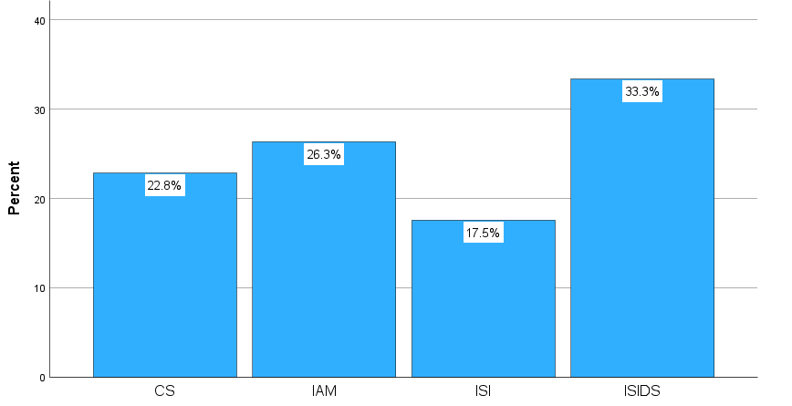

**Figure 3**: Distribution of participants by specialty

The sample is diverse, including students from all four specialties within the computer science department. This diversity helps ensure that the study's findings will apply to the broader population of computer science students at Batna 2 University.

##### What is your level in each Skill?

The responses are coded as 1= Basic, 2=Medium, 3= Good

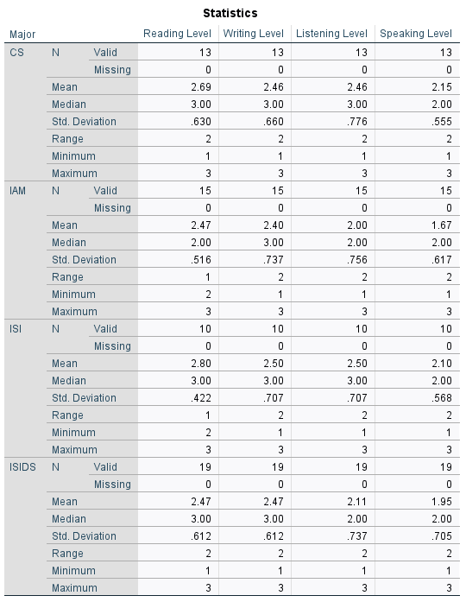

**Figure 4:** students’ proficiency levels in each skill.

**Reading:** The mean reading level for students in the four specialties (CS, IAM, ISI, and ISIDS) ranges from 2.47 to 2.80, with median scores of 2.00 to 3.00. This indicates that, on average, students rate their reading skills as a medium to good across the specialties. The standard deviations range from 0.422 to 0.630, which suggests that there is some variability in the students' reading levels within each specialty group, but not too wide of a range.

**Writing**: the respondents rate their level of writing in English as generally above basic, with mean scores ranging from 2.40 to 2.50 out of three across the distinct groups (CS, IAM, ISI, and ISIDS). The median score is consistently at 3.00, indicating that half of the respondents rate their level of writing as good.

The standard deviation is small, ranging from 0.612 to 0.737, indicating that the ratings are not widely spread out and there is some agreement among respondents. The majority of respondents rated themselves as at least having a medium level of writing proficiency in English.

**Listening**: the mean scores for all groups fall between 2.00 and 2.50, which suggests that they perceive their level of English listening skills to be at a medium level. The median scores of all groups are either 2.00 or 3.00, indicating that the majority of students consider their listening skills to be at a medium or good level. The standard deviation values of all groups are low, which indicates that the responses are not widely dispersed, and the scores are clustered around the mean. In general, the students have a moderate level of confidence in their English listening skills, with some students considering their skills to be good while others feel they are at a basic level.

**Speaking**: the students' self-perceived level in English speaking is lower than their self-perceived levels in other skills. The mean scores for speaking range from 1.67 to 2.15, which falls between Slightly above basic and "Medium". However, the mean score for speaking is lower than the mean scores for the other skills. Additionally, the standard deviation for speaking is low, indicating that there is not much variation in the responses, and most students perceive their speaking level to be in the "Medium" range. The students may feel less confident in their speaking abilities compared to other skills such as reading or writing.

##### Do you Need English in your field?

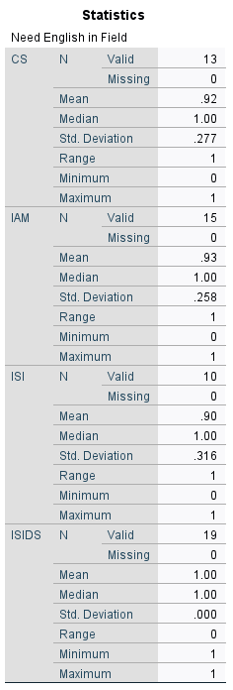The responses are coded as 1= Yes, 0= No

it appears that the students in the CS, IAM, and ISI fields strongly agree that English is necessary for their respective fields, with means ranging from .90 to .93 and a low standard deviation of .258 to .316. This suggests that there is a high level of consensus among the students in these fields that English proficiency is important. Furthermore, in the ISIDS field, all nineteen respondents reported that English is necessary, with a mean of 1.00 and a standard deviation of 0.000, indicating complete agreement among the students in this field. Overall, the data suggests that the majority of students in these fields believe that English proficiency is crucial for success in their field of study.

**Figure 5:** Students’ perceptions on the importance of English in Computer Science

##### What do you need it for

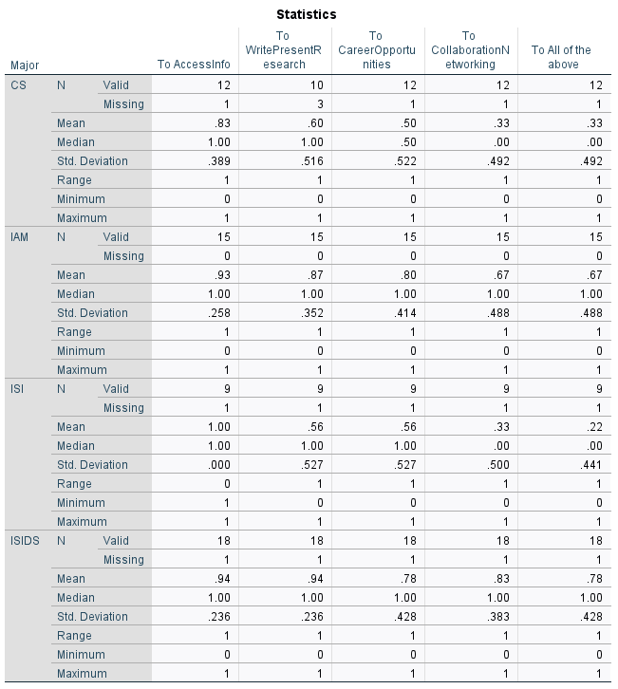The responses for each use are coded as 1= Yes, 0= No

**Figure** **6**: Students’ perceptions on their needs for English in their field.

**To access information relevant to my studies:** the students strongly agree with the statement "To access information relevant to my studies". The mean score for all the groups (CS, IAM, ISI, and ISIDS) ranges from 0.83 to 1.00, with a median score of 1.00, indicating that the majority of students have responded with a "Yes" to the question. The standard deviation is quite low for all groups, ranging from 0.000 to 0.389, which means that the responses are tightly clustered around the mean, indicating a high level of agreement among the students. Overall, it can be concluded that the students believe that accessing information relevant to their studies is important.

To Write and Present Research: the students agree with the statement that they need to write and present research. The mean scores for each group (CS, IAM, ISI, and ISIDS) range from 0.56 to 0.94, with a median score of 1.00 for all groups except for CS (median=0.50). The low standard deviation values for each group indicate that there is little variation in responses, which suggests that the students have a similar perspective on the importance of writing and presenting research.

There are notable patterns observed between the groups. The highest mean score is observed for ISIDS (0.94), indicating that the students in this group strongly agree that writing and presenting research is necessary. The second-highest mean score is observed for IAM (0.87), followed by CS (0.60), and then ISI (0.56). This suggests that the students in the ISIDS and IAM groups place a higher value on research compared to those in the CS and ISI groups.

**Career Opportunities:** there is a high level of agreement among the respondents regarding the importance of future career opportunities. The standard deviation is low for all groups, indicating that the responses are clustered around the mean.

When comparing the groups, the IAM group has the highest mean score, indicating that they place the most importance on future career opportunities. The ISIDS group also has a high mean score, followed by the CS group, and then the ISI group. The median score for all groups is above 0.5, indicating that more than half of the respondents in each group agree that future career opportunities are important.

**Collaboration and Networking:**

The students from the ISIDS group had the highest mean score (0.83) indicating that the majority of them felt that they needed collaboration and networking for their studies. In contrast, the CS and ISI groups had a lower mean score (0.33) indicating that the majority of the students in these groups did not feel the need for collaboration and networking for their studies. The IAM group had a mean score of 0.67, indicating that the majority of students in this group felt the need for collaboration and networking, although to a lesser extent than the ISIDS group.

The standard deviation for all groups indicates that there was a fair amount of variation in responses. However, the ISIDS group had the lowest standard deviation (0.383), indicating that the responses in this group were more consistent than in the other groups.

**All of the above:**

● The majority of students from IAM and ISIDS groups indicated that they need the technology for all of the given purposes (67% and 78% respectively), while only 22% of ISI students and 33% of CS students responded the same way.

● The CS group had the lowest mean (0.33) and median (0.00) response for needing the technology for all of the given purposes, while the ISIDS group had the highest mean (0.78) and median (1.00) response for the same.

● The standard deviation for all groups is close, suggesting that the responses were not to spread out.

● There is a clear contrast in the patterns observed between the IAM and ISIDS groups versus the CS and ISI groups. The former two groups had higher means and medians, indicating that the students in these groups are more likely to need technology for all of the given purposes. In contrast, the latter two groups had lower means and medians, suggesting that the students in these groups are less likely to need technology for these purposes.

**Other (open-question):** Some of the students reported the need for English in writing better code and software development.

##### You use English to:

The responses for each use are coded as 1= Yes, 0= No

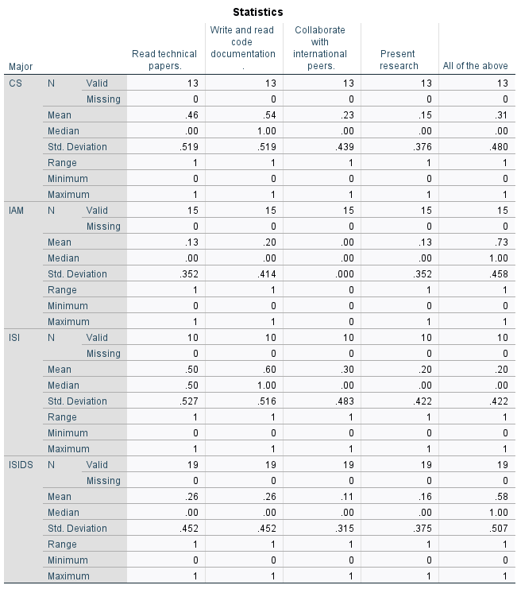

**Figure** **7**: students’ current use of English

The descriptive statistics provided show the students' responses to the question "You use English to:" The activities assessed are **Read technical papers**, **Write, and read code documentation**, **Collaborate with international peers**, **Present research**, and **All of the above.**

For **CS** students, they reported using English the most for Writing and Reading code documentation (mean = 0.54), followed by Reading technical papers (mean = 0.46). They used English the least for Collaborating with international peers (mean = 0.23) and Presenting research (mean = 0.15). Some students used English for all the activities listed (mean = 0.31).

**IAM** students reported using English primarily for All of the above activities (mean = 0.73). When normalizing the means for **IAM** students, they used English more frequently for Writing and reading code documentation (normalized mean = 0.93), Reading technical papers (normalized mean = 0.86), and Presenting research (normalized mean = 0.86). None of the **IAM** students reported using English for Collaborating with international peers.

**ISI** students used English the most for Writing and reading code documentation (mean = 0.60) and reading technical papers (mean = 0.50), followed by Collaborating with international peers (mean = 0.30) and Presenting research (mean = 0.20). A minority of students used English for all the activities listed (mean = 0.20).

Lastly, **ISIDS** students reported using English primarily for All of the above activities (mean = 0.58). When normalizing the means for **ISIDS** students, they used English more frequently for Writing and reading code documentation (normalized mean = 0.84), Reading technical papers (normalized mean = 0.84), Presenting research (normalized mean = 0.74), and collaborating with international peers (normalized mean = 0.69).

In summary, across all majors, students reported using English for a variety of activities, with Writing and reading code documentation and reading technical papers being the most common uses. **IAM** and **ISIDS** students were more likely to use English for all the activities listed, while **CS** and **ISI** students had more specific uses for the language.

##### What English language skills do you think you need to improve for your computer science studies?

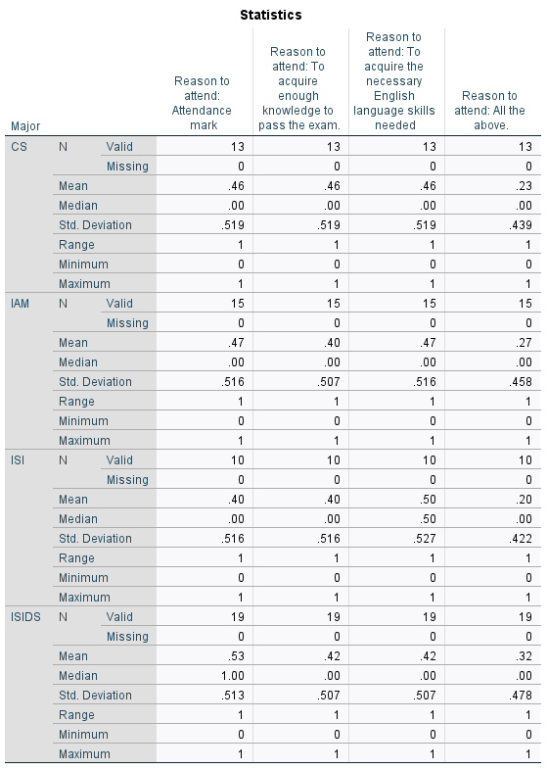The responses for each reason are coded as 1= Yes, 0= No

**Figure** **8**: Students’ perceptions on the language skills they need to improve most.

The descriptive statistics provided give insight into the English language skills that students in different majors feel they need to improve, for their computer science studies.

For **CS** students, the mean scores indicate that they believe they need to improve in Reading, Writing, and Speaking (mean = 0.62) slightly more than Listening (mean = 0.54). However, only a minority of them (mean = 0.38) feel they need to improve in all the language skills mentioned.

**IAM** students feel they need to improve the most in Writing (mean = 0.73) and Speaking (mean = 0.67), followed by

Reading (mean = 0.53) and Listening (mean = 0.40). Only a minority (mean = 0.33) feel they need to improve all their language skills.

**ISI** students have similar concerns in Reading, Listening, and Speaking (mean = 0.70), with a slightly lower need for improvement in Writing (mean = 0.60). Only a minority (mean = 0.40) feel they need to improve all their language skills.

Lastly, **ISIDS** students feel they need to improve the most in Writing and Speaking (mean = 0.68), followed by Reading (mean = 0.58), and Listening (mean = 0.42). A minority (mean = 0.37) feels they need to improve all their language skills.

In summary, across all the majors, students feel they need to improve their Writing and Speaking skills more than their Reading and Listening skills. However, only a minority of students in each major feel they need to improve in all the language skills mentioned.

##### What language skills do you have difficulty with?

The responses for each are coded as 1= Yes, 0= No

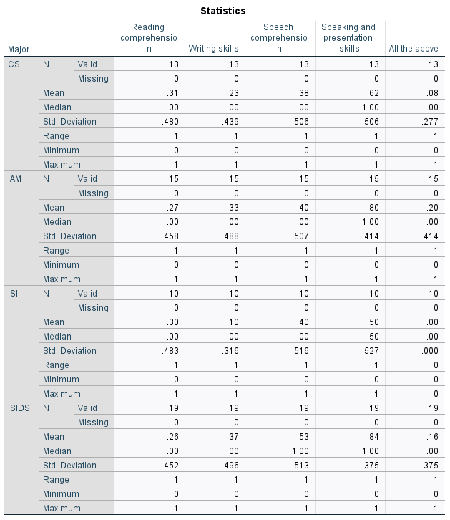

**Figure** **9**: Students’ reported language difficulties

The descriptive statistics provided show the student’s responses to the question "What language skills do you have difficulty with?". The language skills assessed are Reading comprehension, writing skills, Speech comprehension, Speaking and presentation skills, and all the above.

**For CS students**, they reported the highest difficulty with Speaking and presentation skills (mean = 0.62), followed by Speech comprehension (mean = 0.38), Reading comprehension (mean = 0.31), and Writing skills (mean = 0.23). Very few students experienced difficulties in all the language skills (mean = 0.08).

**IAM students** had the most difficulty with Speaking and presentation skills (mean = 0.80), followed by Speech comprehension (mean = 0.40), Writing skills (mean = 0.33), and Reading Comprehension (mean = 0.27). A minority of students struggled with all the language skills (mean = 0.20).

**ISI students** reported the highest difficulty with Speech comprehension (mean = 0.40) and speaking and presentation skills (mean = 0.50). They had less difficulty with Reading comprehension (mean = 0.30) and the least difficulty with Writing skills (mean = 0.10). None of the ISI students reported difficulty in all the language skills.

Lastly, **ISIDS students** experienced the most difficulty with Speaking and presentation skills (mean = 0.84) and Speech comprehension (mean = 0.53), followed by Writing skills (mean = 0.37) and Reading Comprehension (mean = 0.26). A minority of students had difficulty with all the language skills (mean = 0.16).

In summary, across all majors, students reported the highest difficulty with Speaking and presentation skills, followed by Speech comprehension. Reading comprehension and Writing skills were less challenging for the students. Only a small minority of students in each major reported difficulty in all the language skills assessed.

##### What kind of assessment do you prefer?

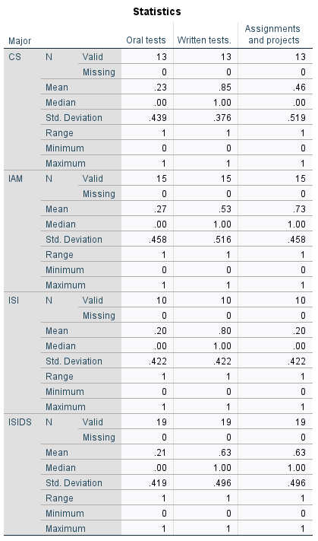The responses for each are coded as 1= Yes, 0= No

**Figure 10**: Students’ preferred assessment.

Based on the given descriptive statistics, it can be interpreted that the students' preferences for types of testing vary across the different groups. For oral tests, the mean values are low for all groups, with CS and ISI having the lowest mean values. This indicates that oral tests are not a preferred type of testing for most students. For written tests, the mean values are high for all groups, with ISI having the highest mean value. This indicates that written tests are the preferred type of testing for most students. For assignments and projects, the mean values are mixed, with IAM and ISIDS having the highest mean values, indicating that some students prefer this type of testing. The standard deviations are consistent across all four groups, indicating that the responses are consistent within each group. Overall, the students prefer written tests, while oral tests are not preferred by most students. Assignments and projects are a mixed preference among students, with some students preferring this type of testing and others not.

### 3.2.2 Motivation and Engagement.

#### 3.2.2.1 Based on the Interview:

1. Student Motivation: According to the teacher Initially, attendance was not impressive, but more students began attending in large numbers. The teacher believes that students are motivated both intrinsically and extrinsically. Students engage, interact, and ask questions in class, with some RSD students also attending despite not having an English course for the first semester

#### 3.2.2.2 Based on the Questionnaire.

##### How often do you attend?

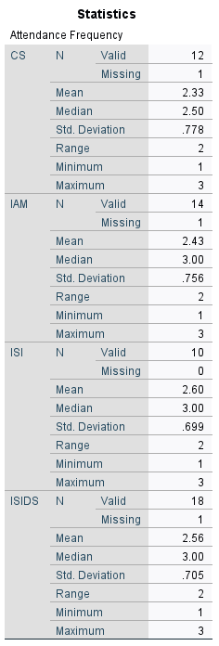 The data provided represent the attendance frequency of students in four different groups: CS, IAM, ISI, and ISIDS. The responses are coded as one for "Always", two for "Often", and three for "Rarely". There are no responses for "Never" (coded as 4).

For the CS group, the mean attendance frequency is 2.33, with a median of 2.50, indicating that students tend to attend between "Often" and "Rarely". The standard deviation is 0.778, which suggests a moderate spread in responses. The range of two shows that responses vary from "Always" to "Rarely".

In the IAM group, the mean is 2.43 and the median is 3.00, suggesting that students typically attend "Rarely". The standard deviation is 0.756, and the range of responses is also two, covering "Always" to "Rarely".

**Figure 11:** Students’ attendance frequency

For the ISI group, the mean attendance frequency is 2.60, with a median of 3.00, indicating that students attend "Rarely". The standard deviation is 0.699, showing a moderate spread in responses. The range is two, with responses varying between "Always" and "Rarely".

Lastly, the ISIDS group has a mean of 2.56 and a median of 3.00, suggesting that students in this group also tend to attend "Rarely". The standard deviation is 0.705, and the range of responses is two, covering "Always" to "Rarely".

In summary, all four groups have a similar pattern of attendance frequency, with the majority of students attending "Rarely". The data shows a moderate spread in responses, with the range covering "Always" to "Rarely" for all groups.

##### What motivates you to Attend?

The responses for each are coded as 1= Yes, 0= No

**Figure 12:** Students’ motivation for attendance

**Attendance mark:** Across all groups, the mean value of the responses is around 0.46 to 0.53, which indicates that the majority of the students attended the course to some extent to obtain attendance marks. However, the median values are zero, which indicates that at least 50% of the students did not attend the course for this reason.

The standard deviation is high for all groups, ranging from 0.516 to 0.519, which indicates that the responses were quite varied within each group.

Overall, the statistics suggest that while attendance marks were a motivating factor for many students to attend the English course, a significant number of students did not attend the course for this reason. Additionally, there was a considerable variation in the responses within each group.

**To acquire enough knowledge to pass the exam:**

The data shows the responses of students regarding their reason for attending the English course. The reason was to acquire enough knowledge to pass the exam. The descriptive statistics suggest that the majority of the students did not attend the course with the sole purpose of passing the exam, as the mean scores for all four variables (CS, IAM, ISI, and ISIDS) are below 0.5. This means that, on average, less than half of the students attended the course to pass the exam. The standard deviation for each specialty is high, indicating a wide range of responses among the students. The median scores for all variables are zero, which confirms that the majority of students did not attend the course to pass the exam. Overall, the data suggest that the students had a variety of reasons for attending the English course and passing the exam was not the only motivating factor.

**To acquire the necessary English language skills needed:**

the students' responses are mixed regarding their reason for attending the English course to acquire the necessary language skills needed. The mean values for CS, IAM, and ISIDS are less than 0.5, indicating that less than half of the students answered "Yes" to the question. The mean value for ISI is slightly higher than 0.5, indicating that slightly more than half of the students answered "Yes" to the question. However, the median value for all four groups is zero, indicating that more students responded "No" than "Yes" to the question. The standard deviations are similar across all four groups, indicating that the responses are fairly consistent within each group. Overall, there is not a clear consensus among the students on the reason for attending the English course.

**All of the above:**

the students' responses to the question of attending the English course for all the above reasons are low. The mean values for CS, IAM, and ISI are less than 0.3, while the mean value for ISIDS is slightly higher at 0.32. This indicates that a small proportion of students (less than one-third) answered "Yes" to the question. The median value for all four groups is zero, indicating that the majority of students responded "No" to the question. The standard deviations are similar across all four groups, suggesting that the responses are consistent within each group. Overall, the students do not have a strong inclination to attend the English course for all the above reasons.

In summary, the descriptive statistics provide insights into the students' motivations for attending the English course. The attendance mark was a motivating factor for many students, but not for all, as there was a significant variation in responses. Passing the exam was not the sole reason for attending the course, and a majority of the students did not attend the course for this reason. The acquisition of necessary language skills was a mixed reason for attendance, with no clear consensus among the students. Finally, attending the course for all the above reasons was not a significant motivation for the majority of students. Overall, the descriptive statistics reveal that students had varied reasons for attending the English course.

## 3.3 Course Syllabus Design Findings

### 3.3.1 Course Content and Structure.

Overview of the syllabus content and its relation to the student’s needs, based on the analysis of the syllabus document and the teacher's interview.

#### 3.3.1.1.1 Based on the Interview.

Syllabus/Course Design: The teacher reports that the design of the syllabus is based on classroom observation and student needs, using a competency-based approach. While the department recommended a syllabus, the teacher had the autonomy to be creative in designing the course. The syllabus was approved by the department. The teacher also reported receiving assistance from ESP teachers at the Department of English and Literature.

Course Evaluation: The teacher reports not evaluating the effectiveness of the course, and the only indication of effectiveness is through student marks.

#### 3.3.1.1.2 Based on the analysis of the syllabus document provided.

Syllabus Content:

Section 1: Basic English

* 1. Introduction to Basic English Grammar
     + Simple past, present, and future tense
  2. Basic Vocabulary
     + Plural forms, countable/uncountable nouns, quantifiers, articles, possessive 's'
  3. Simple Tasks
     + Text reading comprehension, gap filling, paragraph writing, matching activities

Section 2: Complex English (More Specified)

1. Advanced Grammar
   * + Present/past perfect/continuous, conditional sentences (IF clause)
2. Specialized Vocabulary
   * + Research methodology terms, analysis of scientific research proposals related to computer science.
3. Complex Tasks
   * + Developing a research proposal (collaborating with research methodology teachers)

Learning Outcomes:

Upon completion of this course, students will be able to:

1. Writing
   * + Write and produce accurate scientific articles related to computer science.
2. Listening
   * + Listen to and understand scientific terms and discussions in their field.
3. Reading
   * + Read and comprehend scientific articles and research papers in computer science.
4. Speaking
   * + Present their scientific research proposals effectively and confidently in public settings.

### 3.3.2 Teaching Methods and Strategies.

Description of the teacher's methods and strategies used in the ESP course, based on the teacher's interview and the syllabus document.

#### 3.3.2.1.1 Based on the Teachers’ Interviews.

ESP Session Structure: The teacher prepares a lesson plan and tools such as a slideshow before beginning the lesson. The session includes warm-up activities, reading of student samples, and a combination of theoretical and practical parts. The teacher reports using a collectivist/holistic approach to teaching, with projects and pair/group work being the most common activities. The teacher uses authentic materials and incorporates technology such as personal computers and projectors into the course. The teacher cannot modify the classroom environment as the session is always held in the amphitheater. The teacher also uses positive reinforcement in the form of extra marks

### 3.3.3 Students' Perception of the Course Syllabus.

Analysis of students' opinions about the syllabus, its relevance, and effectiveness, informed by the student questionnaire.

##### To what degree does the current English course meet your needs?

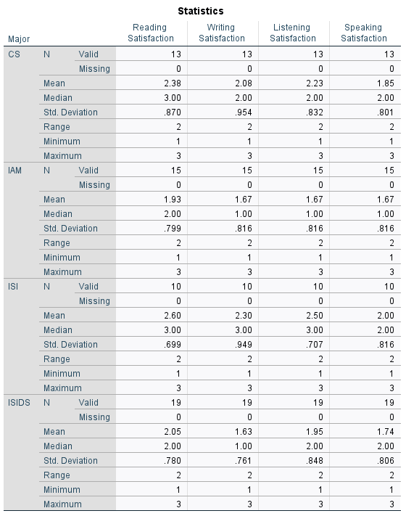The responses for each are coded as 1= Not at all, 2= Somewhat, 3=Completely

**Figure 13**: Students’ perceptions on the course’s alignment with their needs.

The descriptive statistics provided show the student’s responses to the question "To what degree does the current English course meet your needs?" The areas of satisfaction assessed are Reading Satisfaction, Writing Satisfaction, Listening Satisfaction, and Speaking Satisfaction.

**CS** students reported the highest satisfaction in Reading (mean = 2.38), followed by Listening (mean = 2.23), Writing (mean = 2.08), and the lowest satisfaction in Speaking (mean = 1.85).

**IAM** students reported the lowest satisfaction across all areas compared to other majors. They reported slightly higher satisfaction in Reading (mean = 1.93) than in Listening, Writing, and Speaking (all with a mean = 1.67).

**ISI** students had the highest satisfaction in Reading (mean = 2.60) and Listening (mean = 2.50), followed by Writing (mean = 2.30), and Speaking (mean = 2.00).

Lastly, **ISIDS** students reported the highest satisfaction in Reading (mean = 2.05), followed by Listening (mean = 1.95), Speaking (mean = 1.74), and the lowest satisfaction in Writing (mean = 1.63).

In summary, across all majors, students reported higher satisfaction with the Reading and Listening aspects of the English course, while lower satisfaction was reported for Writing and Speaking. The satisfaction levels for each aspect varied among the different majors, with ISI students reporting the highest satisfaction levels and IAM students reporting the lowest satisfaction levels overall.

##### Which of the following does your teacher of English use most?

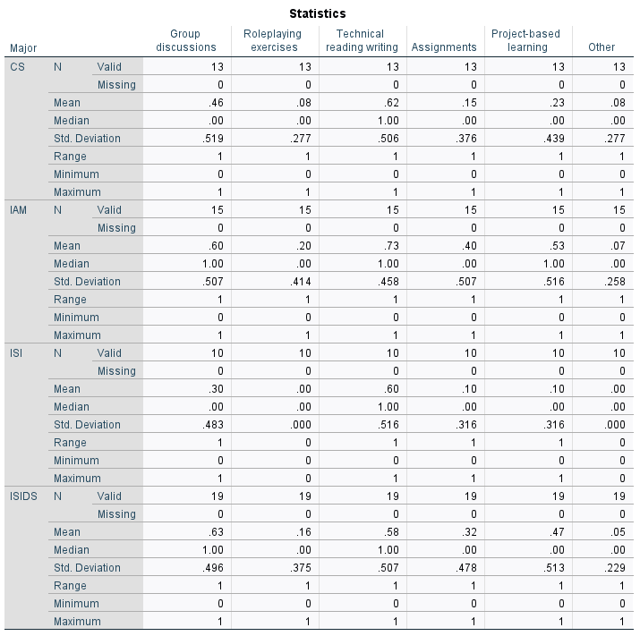The responses for each column are coded 1= Yes, 0= No

**Figure 14:** Students’ perceptions on the teaching activities used most.

The descriptive statistics provided show the student’s responses to the question "Which of the following does your teacher of English use most?" The teaching methods assessed are Group discussions, Roleplaying exercises, technical reading writing, Assignments, Project-based learning, and “Other.”

For **CS** students, the most commonly used teaching method was technical reading writing (mean = 0.62), followed by Group discussions (mean = 0.46). The least common methods were Roleplaying exercises and Other (both with a mean = 0.08). Assignments and Project-based learning had means of 0.15 and 0.23, respectively.

**IAM** students reported the highest use of technical reading writing (mean = 0.73), followed by Group discussions (mean = 0.60) and Project-based learning (mean = 0.53). The least common method was Other (mean = 0.07). Roleplaying exercises and Assignments had means of 0.20 and 0.40, respectively.

**ISI** students also experienced the highest use of technical reading writing (mean = 0.60), followed by Group discussions (mean = 0.30). The least common methods were Roleplaying exercises and Other (both with a mean = 0.00). Assignments and Project-based learning had mean values of 0.10 each.

Lastly, **ISIDS** students reported the highest use of technical reading writing (mean = 0.58) and Group discussions (mean = 0.63), followed by Project-based learning (mean = 0.47). The least common method was Other (mean = 0.05). Roleplaying exercises and Assignments had means of 0.16 and 0.32, respectively.

In summary, across all majors, students reported that their English teachers used technical reading writing the most, followed by Group discussions. Roleplaying exercises and Other were the least used methods. Assignments and Project-based learning were used to varying degrees depending on the major.

##### Does it/ do they help you improve your needed skills?

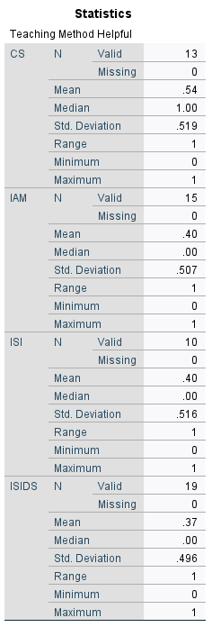The responses for each column are coded 1= Yes, 0= No

**Figure 15**: Students’ perceptions on the success of the teacher’s teaching activities in improving their needed skills

The descriptive statistics provided show the student’s responses to the question "Does it/do they help you improve your needed skills?"

For **CS** students, the mean response was 0.54, with a median of 1.00, indicating that more than half of the students found the teaching methods helpful in improving their needed skills.

**IAM** students had a mean response of 0.40 and a median of 0.00, suggesting that the majority of students in this major did not find the teaching methods helpful in improving their needed skills.

ISI students also had a mean response of 0.40 and a median of 0.00, which indicates that most students in this major did not find the teaching methods helpful in improving their needed skills.

Lastly, **ISIDS** students had a mean response of 0.37 and a median of 0.00, implying that the majority of students in this major did not find the teaching methods helpful for improving their needed skills.

In summary, **CS** students found the teaching methods helpful in improving their needed skills, while students in **IAM**, **ISI**, and **ISIDS** majors mostly did not find the teaching methods helpful, as well as the considerable remainder of **CS** students who reported their dissatisfaction.

##### If “No” what learning methods do you think would be more suitable?

Thematic Analysis:

Using a qualitative thematic analysis. We have identified the following themes:

1. Overcoming fears and promoting discussions: Several respondents suggested that students should be provided with more opportunities to overcome their fears and engage in discussions and dialogues.

2. Importance of an understanding and skilled professor: Some students believe that having a professor who is understanding and good at teaching would make a difference in learning English more effectively.

3. Seeking help from education experts: A few respondents recommend seeking help from education experts to determine more suitable learning methods.

4. Uncertainty about alternatives: Some students are unsure about alternative learning methods that would be more suitable for them.

In the context of our study, these findings suggest that students who do not find the current teaching methods effective are interested in exploring alternative approaches. They want to focus on overcoming their fears, engaging in discussions, and having a supportive and skilled professor. Additionally, seeking help from education experts might provide valuable insights into more suitable teaching methods that can be incorporated into the course design.

##### Do you find the teacher’s usage of ICT helpful?

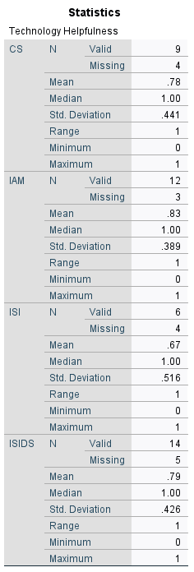The responses for each column are coded 1= Yes, 0= No

**Figure 16:** Students’ perceived helpfulness of teacher’s use of ICT tools

The descriptive statistics provided show the students’ responses to the question "Do you find the teacher’s usage of ICT tools helpful?" regarding the incorporation of technology into their English courses.

For **CS** students, the mean response was 0.78, with a median of 1.00, indicating that the majority of these students found the use of technology in their English courses helpful.

**IAM** students had a mean response of 0.83 and a median of 1.00, suggesting that most students in this major found the use of technology in their English courses helpful.

**ISI** students had a mean response of 0.67 and a median of 1.00, which indicates that the majority of students in this major also found the use of technology in their English courses helpful.

Lastly, **ISIDS** students had a mean response of 0.79 and a median of 1.00, implying that most students in this major found the use of technology in their English courses helpful.

In summary, students across all majors reported that they found the incorporation of technology into their English courses helpful, with IAM students experiencing the highest levels of perceived helpfulness.

##### Do you think the passages and exercises in the course are relevant to your field of study?"

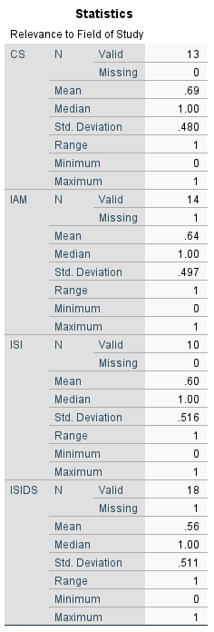The responses for each column are coded 1= Yes, 0= No

**Figure 17**: Students’ perceptions on the relevance of the passages and exercises in the course.

Based on the given descriptive statistics, it can be interpreted that the majority of students perceive the passages and exercises in the English course to be relevant to their field of study, with means slightly above 0.5. The mean values for CS, IAM, and ISI are above 0.6, indicating that more than 60% of students responded "Yes" to the question. The mean value for ISIDS is slightly lower at 0.56, indicating that just over half of the students responded "Yes." However, a considerable minority of students responded "No" to the question, as evidenced by the standard deviations, which are high across all four groups. The median values for all groups are 1.00, indicating that the majority of students responded "Yes" to the question. Overall, the data suggests that while the majority of students perceive the passages and exercises in the English course to be relevant to their field of study, there is a notable proportion of students who do not share this view.

##### A screenshot of a computer Description automatically generated with low confidenceDo you think the passages and exercises in the course are within your reach?

The responses for each column are coded 1= Yes, 0= No

Based on the given descriptive statistics, it can be interpreted that the students' responses regarding whether they think the passages and exercises in the course are within their reach are positive. The mean values for all groups are above 0.7, indicating that a majority of the students answered "Yes" to the question. The median values for all groups are 1.00, which confirms that most students feel that the passages and exercises are within their reach. The standard deviation is consistent across all four groups, indicating that the responses are consistent within each group. Overall, the majority of students feel that the passages and exercises in the English course are within their reach.

**Figure 18:** Students’ perceptions on the appropriateness of the passages and exercises in the course.

##### The exams you take in the English class are:

The responses for each column are coded 1= Too hard, 2= Within reach, 3=Too easy

Based on the given descriptive statistics, it can be interpreted that the majority of students found the exams in the English class to be within their reach. The mean values for all four groups are above 2.00, which is the midpoint of the scale, indicating that on average, students found the exams to be "within their reach". The median values for all four groups are also 2.00, which confirms that most students found the exams neither too hard nor too easy. The standard deviations are consistent across all four groups, indicating that the responses are consistent within each group. However, there is some variation in the responses, with a few students finding the exams either too hard or too easy. Overall, most students found the exams to be at an appropriate difficulty level.

**Figure 19:** Students’ perceptions on the appropriateness the assessment in the English class.

##### Do your grades in English accurately reflect your language proficiency?

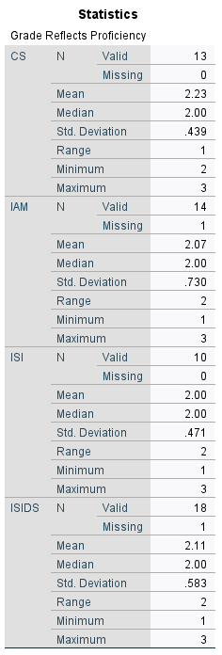The responses for each column are coded 1= Yes, 2= Neutral, 3=No

Based on the given descriptive statistics, it appears that the majority of students have a 'neutral reach' opinion on whether their grades in English accurately reflect their language proficiency, with some slight variations towards 'no'.

Across all specialties—CS, IAM, ISI, and ISIDS—the consensus was generally 'Neutral' on whether English grades accurately reflected language proficiency. CS had the highest mean (2.23), indicating a lean towards 'No'. IAM had a mean value of 2.07, leaning towards 'Neutral' but somewhat closer to 'Yes'. ISI was exactly 'Neutral' with a mean of 2.00, and ISIDS leaned slightly towards 'No' with a mean of 2.11. Overall, most students across specialties were neutral

**Figure 19:** Students’ perceptions on whether their grades in the English class reflect their level

##### If "No" Why?

Descriptive Analysis: Unfortunately, there were no responses from the eight respondents applicable to this question, So, an analysis of the results is not possible.

##### Do you think the teacher’s feedback helps you improve your language performance?

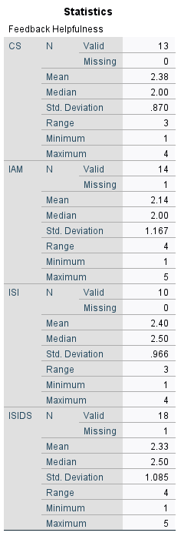The responses are coded as 1=Very helpful, 2=Somewhat helpful, 3=Neutral ,4= Not very helpful, 5= Not helpful at all.

Based on the given descriptive statistics, it can be interpreted that the majority of students perceive the teacher's feedback to help improve their language performance, although there are some mixed opinions as well. The mean values for each group are above the midpoint of two, indicating that on average, students consider the feedback to be at least helpful. The median values are at or above 2, suggesting that the majority of students responded positively to the question. The standard deviations are high across all groups, indicating that there is a wide range of opinions on the helpfulness of feedback within each group. Overall, it can be concluded that students value the teacher's feedback and find it helpful in improving their language performance, although individual opinions and experiences may vary.

**Figure 20**: Students’ perceptions on the helpfulness of teacher’s feedback in improving their language performance.

## 3.4 Challenges and Suggestions for Improvement

Discussion on the challenges and suggestions provided by the teacher during the interview and the students' input from the questionnaire.

### 3.4.1 Based on the Interview.

Challenges and Suggestions for Improvements:

1. Challenges Faced: The teacher initially faced the challenge of low attendance, but this was addressed by explaining the importance of attending the course.

2. Suggestions for Improvement:

1. The teacher also mentioned that the coefficient is detrimental to motivation levels and that a higher coefficient would result in higher motivation and more attendance rates.

2. The teacher reported that there is a large number of students spread into five specialties, and the teacher faces difficulty designing courses specific to their specialties but still tries to provide materials that are specific and relevant to each specialty as possible.

3. The teacher acknowledged that further formal ESP training would be beneficial to them by providing a better ESP course.

4. Increasing the frequency of the course to twice a week

### Based on the Questionnaires.

#### Is the time allotted to the English session:

The responses are coded 1= Enough, 2= Not Enough

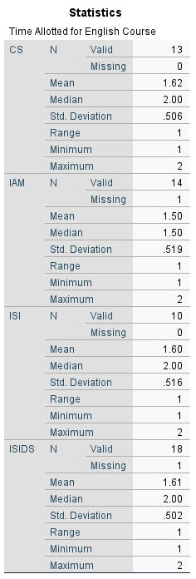Based on the given descriptive statistics, it can be interpreted that the student’s responses to the question of whether the time allotted to the English session was sufficient are negative. The mean values for CS, ISI, and ISIDS are less than 0.5, indicating that less than half of the students felt that the time allotted was sufficient. The mean value for IAM is 0.50, which is exactly at the midpoint, indicating a mixed response. The median value for all four groups is zero, indicating that the majority of students responded "No" to the question. The standard deviations are similar across all four groups, suggesting that the responses are consistent within each group. Overall, the majority of students did not feel that the time allotted for the English course was sufficient, with some students having mixed opinions.

**Figure 21**: Students’ perceptions on the allotted time’s sufficiency

#### If “Not enough”, do you think it should be extended:

The responses are coded 1= Yes, 0= No

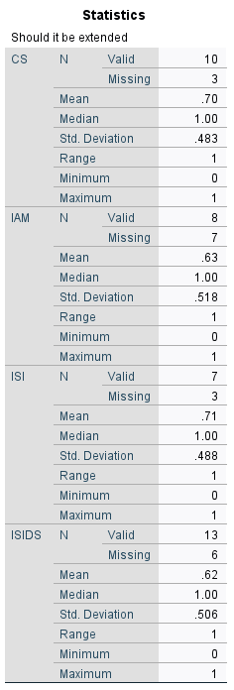

Based on the given descriptive statistics, it can be interpreted that the student’s responses to the question of whether the time allotted to the English session should be extended if they felt it was not enough generally positive. The mean values for all four groups (CS, IAM, ISI, and ISIDS) are above 0.62, indicating that the majority of students who felt that the time allotted was not enough answered "Yes" to the question of whether it should be extended. The median values for all four groups are 1.00, indicating that more students responded "Yes" than "No" to the question. The standard deviations are consistent across all four groups, indicating that the responses are consistent within each group. Overall, it appears that the majority of students who felt that the time allotted was not enough are in favor of extending it, although some students have mixed opinions.

**Figure 22**: Students’ preferences for allotted time extension

#### “Do you Prefer English Courses to be in-class or online?”

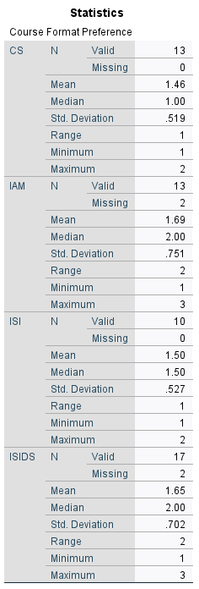The descriptive statistics provided show the student’s responses to the question "Do you prefer the English course to be in-class or online?" With three answering options 1=In-class, 2=Online, 3=Both

For CS students, the mean response was 1.46, with a median of 1.00, indicating a mixture of preferences with a slight inclination towards in-class learning.

IAM students had a mean response of 1.69 and a median of 2.00, indicating a mixture of preferences with a slight inclination towards online learning.

ISI students had a mean response of 1.50 and a median of 1.50, which suggests a balanced mixture of preferences between in-class and online learning.

Lastly, ISIDS students had a mean response of 1.65 and a median of 2.00, implying a mixture of preferences with a slight inclination towards online learning.

In summary, there is no clear consensus among students across the different majors about their preference for in-class or online English courses.

**Figure 23**: Students’ preferences for in-class or online courses

#### Why do you prefer it that way?

Based on a thematic analysis of the responses, the following key themes emerge for why students prefer a particular course format:

1. Time and convenience: Some students prefer a specific format due to time constraints or the convenience it offers. For example, one student mentioned preferring online courses because they save time.

2. Technological advancements: Some students believe that online courses are better suited for the current digital age and are more comfortable with technology.

3. Better understanding: A few students mentioned that they prefer one format over the other because they believe it helps them understand the material better.

4. Personal support from professors: Some students appreciate in-person courses because they feel that the professor can correct and direct them more effectively in this setting.

5. Connectivity issues: One student mentioned difficulty connecting to the internet at their residence, which might have led to their preference for in-class courses.

6. Preference for a blended approach: A few students believe that both in-class and online formats should be used since different topics or aspects of learning might be better suited for one format over the other.

It is worth noting that several responses were unclear or did not provide a specific reason for their preference.

#### “What Challenges do you face when learning English?”

Thematic Analysis:

1. Speaking and communication:

● Several students mentioned difficulties with speaking, communication with foreigners, and the shame of speaking about it as their main challenges.

2. Pronunciation:

● A few students highlighted the correct pronunciation as a challenge they face when learning English.

3. Time management:

● Shortage of time was mentioned by some students as a challenge they face when learning English.

4. Comprehension of programming instructions:

● A couple of students mentioned challenges in understanding programming instructions in English.

5. Self-assessment and self-development:

● One student mentioned difficulty in speaking and evaluating their self-development.

6. No challenges or not specified:

● Some students reported no challenges or left the question unanswered. This could indicate that these students are already comfortable with their English language skills, or they may not have any specific challenges that they can identify at the moment.

#### Do you prefer English as the instruction language in other Computer Science courses?

The responses are coded 1= Yes, 0= No

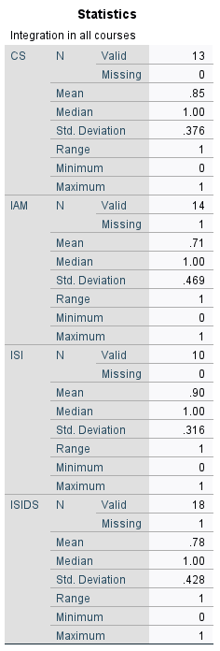Based on the given descriptive statistics, it can be interpreted that the majority of students preferred English was used as the instruction language in the other Computer Science courses. The mean values for all four groups are above 0.7, with ISI having the highest mean value of 0.90. This indicates that most students answered "Yes" to the question. The median values for all four groups are 1.00, indicating that more students responded "Yes" than "No" to the question. The standard deviations are consistent across all four groups, indicating that the responses are consistent within each group. Overall, the students were in favor of English being used as the instruction language in other Computer Science courses.

**Figure** **24**: Students perceptions on English as the instruction language in other Computer Science courses

#### “Please feel free to add any ideas or comments concerning the English class.”

A Thematic Analysis:

● General preference for studying in English as it is considered the language of the world and important for future success.

● Suggestions for more use of the Internet in the English class.

● Suggestions for the teacher to focus on all students, not just the strong ones in the language, and to use simple methods for better learning.

● Suggestion to incorporate computer-based learning methods, such as photos and plans, to help with memory consolidation.

● Preference for gradual integration of English into full specialization.

● Overall, there is a lack of responses, with many empty or no response entries.

## 3.5 Discussion:

### Key Factors Influencing the Effectiveness of the ESP Course.

Initially, the teacher had issues with attendance, but this was resolved overtime. The teacher, by effectively explaining the value and importance of the ESP course, managed to motivate students to attend more frequently. This increased attendance is evidence of a shift in student perception of the course's value, directly resulting from the teacher's efforts. The students’ questionnaire data reveal that students understand the importance of the English language in their field. And the insights into their motivations for attending the English course, suggest that many of them do in fact understand the value of the ESP course as they are motivated both intrinsically and extrinsically, which aligns with the teacher’s perceptions.

Administration can influence how the ESP course is perceived by students. If the administration places a higher value on the course by increasing the coefficient as the teacher suggested and integrates the course according to the needs of the students within the overall computer science curriculum, the course is more likely to be seen as valuable by the students as well.

The administration is also inclined to provide appropriate materials and allocate more resources for hiring and training suitable and qualified staff. The teacher, for instance despite being able to overcome Student Motivation issues, which is a highly commendable effort, reported having only a year's experience in teaching ESP and lacking formal training in the subject. They also reported that they would appreciate opportunities to enhance their expertise through formal ESP training relevant to computer science. Belcher (2006) highlights the importance of ESP instructors possessing expertise in both the target language and the specific field they are teaching in order to address students' unique needs effectively.

This effective communication between the administrative body, the instructors, and students about the perceived importance of the course can motivate the students to attend the class more frequently and engage more actively with the course, leading to better outcomes.

Communicating the importance of the course is not the only responsibility the administration holds that can significantly influence the course. The administrative policies should support flexibility and adaptability in the ESP course design according to the needs of the students. For instance, both students and the teacher reported that the allotted time for the course was not enough. And they were in favor of extending it. However, extending the time for the course would ultimately conflict with students’ reported challenge of time constraints. The students and the teacher were asked about using English as a language of instruction in other courses, and they were in favor of it. This would decrease the students’ language problems by exposing them to more materials in English and would solve the time constraints problem. Extending the allotted time for the course or changing the language of instruction of other courses is ultimately bound to administrative policies. The hegemony of English in computer science as language of educated exchange and the time constraints faced by the students suggest that using English in other courses is the best option and would align with students’ needs, resulting in a higher motivation and therefore better learning outcomes.

### The Alignment between the ESP course syllabus and Students Language Needs.

The teacher is responsible for identifying the learners’ Language Situation. The teacher reported not conducting a preliminary formal investigation and relying solely on classroom observation. While classroom observation and interaction are commendable efforts, a more comprehensive approach is of utmost necessity (Basturkmen, 2010). The ESP teacher's lack of a formal investigation at the beginning of the course may hinder their ability to fully understand the students’ language situation. For instance, the instructor’s perception of students' language proficiency levels does not entirely align with the students' self-reported levels. The comparison between the two reveals some discrepancies, particularly in reading and speaking.

While students rate their reading skills as medium to good (mean scores 2.47-2.80 out of 3), the teacher perceives them to struggle in this area. Another slight misalignment occurs in speaking, where students report their skills as slightly above basic to medium (mean scores 1.67-2.15 out of 3), while the teacher perceives them to struggle in this area considerably. This is understandable from the teacher’s part due to the fact that speaking is reported as the weakest skill by students. In contrast, students' self-reported writing abilities (mean scores 2.40-2.50 out of 3) align with the teacher's perception. For listening, students perceive themselves to be at a medium level (mean scores 2.00-2.50 out of 3), which is slightly lower than the teacher's perception but still similar.

When the students were asked about what language skills, they felt they needed to improve, in a separate question, students across all the majors generally felt the need to improve their Writing and Speaking skills more than Reading and Listening skills. Difficulties with oral expression were also reported in the challenges section. This is consistent with the teacher’s perception that the students have difficulties in the verbal aspect of language production.

Another issue that arises from not using a formal investigation of the learners’ language situation at the beginning of the course, is the teacher’s lack of understanding of the diverse needs of Master 1 Computer Science students. The Teacher emphasized the students’ need for mastering research writing and presentation. Although this is especially true for Master 1 students, The teachers’ answers showed a lack of understanding about the diverse needs and uses of the English language by the students. The students acknowledged the importance of the English language in their field, but they did not limit its uses to only dissertation writing. The students reported the crucial need for the English language in writing better code and software development. In fact, some students reported having challenges understanding Code Documentation due to their lack of English proficiency, further reinforcing the importance of English in this area. They also highlighted the need for English in accessing information relevant to their field, networking and collaborating with peers, as well as for future career opportunities. The students also reported actually using English for a variety of activities, with Writing/Understanding Code Documentation as well as reading technical papers being the most common uses. IAM and ISIDS students were more likely to use English for all activities listed, while ISI and CS students had more specific uses for the language.

The teacher highlights their use of a competency-based approach in designing an English for Specific Purposes (ESP) course, which is consistent with the learning-centered approach presented in Hutchinson and Waters' (1987) seminal work. The teacher appreciated the autonomy they had been granted, which allowed them to be creative in developing the course content. They also acknowledged the support they received from fellow ESP teachers in the Department of English and Literature. The teacher reported designing the syllabus based on the data obtained through classroom observations.

Indeed, While the teacher's approach is aligned with ESP principles in general and the learning-centered methodology, designing a syllabus based on the data obtained through classroom observation, which on its own may not a very reliable method for investigating the needs for this context (Brown, 1995, Richards, 2002, Kumar 1996), would result in a syllabus design that does not effectively address the students’ needs and preferences. Since there are discrepancies between the teacher’s perceptions and the data collected from the students, it is fair to say the syllabus is not aligned with the students’ specific language needs. This can explain the students’ feedback about the effectiveness of the ESP course in improving their language skills, where the students generally reported higher satisfaction with Reading and Listening aspects of the English course, while lower satisfaction was reported for Writing and Speaking. This is problematic since writing and speaking are specifically the skills the students reported the need to improve most based on the data collected. Literature stresses the importance of the four language skills for Computer Science students equally (Beaubouef, 2003).

From the Literature a course syllabus is the statement of the aims and objectives of a course, the content to be covered, the methodology to be used, the materials and resources to be employed, the assessment procedures to be followed, and the time frame for the course.

Following these guidelines when reviewing the provided syllabus document, we can observe that the teacher’s syllabus document includes statement of the aims and objectives of the course, the content to be covered. However, it fails to account for the methodology to be used, the materials and resources to be employed, the assessment procedures to be followed, and the time frame for the course. The teacher should consider being explicit in writing their syllabus document, as it plays a significant role for the understandability and transparency (Robinson, 1991).

Fortunately, the data collected through the teacher’s interview as well as the students’ questionnaire helped in understanding the elements missing from the syllabus document.

Teacher reported employing a “collectivism\holistic” approach with projects, written assignments, and pair/group work being the most common activities. the teacher also mentioned the use authentic materials and resources such as Computer Science research proposals, and the incorporation of ICT tools such as personal computers and projectors into the course, in addition to utilizing Moodle which is a modern platform for Virtual Learning in the second semester.

The students on the other hand reported that their English teacher used a variety of activities, with technical reading/writing being most used, followed by Group discussions. Other activities were reported by the students to be used to a lesser degree. However, the students' perceived effectiveness of these methods varied across different majors. A slight majority Students in the CS major found the teaching methods helpful, whereas those in IAM, ISI, and ISIDS majors did not find them as beneficial. This misalignment suggests that the teaching methods may need to be adjusted or diversified according to the specific needs of students in different majors, including those from IAM, ISI, and ISIDS, as well as a considerable number of CS students who reported dissatisfaction. In terms of materials and resources use, the majority of the students reported that they found the passages relevant to their field of study. They also reported positive feedback when asked if they have found the teacher’s use of ICT tools helpful. The teacher’s efforts to make the class as relevant as possible are commendable, However, it is important to note that the materials and tools used should be engaging and relevant to the field, the specific goals of the class, needs and abilities of the learners and the availability of the appropriate technology as well as the ability of the instructor to use those materials. Data collected from the students suggests that Master 1 Computer Science students would benefit from more appropriate tools and materials that cover their diverse needs in their specific specialties. Unfortunately, such tools and materials may be unavailable (considering the context of the department), and the teacher may not be trained to use them.

In another point, Students reported the passages are within their reach. This is a good indicator for the appropriateness of the syllabus contents to the level of students. However, when analyzing the syllabus document. it appears that the syllabus is heavily focused on basic English skills in Section 1, which may not be as relevant or useful for Master 1 computer science students who already have a strong foundation in general English as shown by the descriptive statistics. The students' self-assessment across the four specialties (CS, IAM, ISI, and ISIDS) reveals that their English language foundation is generally rated as medium to good. This means that the course should be more focused on specialized and complex activities tailored to the needs of Master 1 computer science students that aim to challenge and improve the abilities of learners while being at an acceptable level of difficulty. Basic English is an essential part of any English syllabus, but the size and focus of it should depend on the learners’ nature. This can help make better use of the allotted time for the ESP course, which is limited to 1:30hrs per week.

Similarly, the syllabus could benefit from incorporating more collaborative and problem-solving activities throughout the course. This would help students build teamwork and communication skills, which are essential in the computer science field.

In addition, it can be observed from the questionnaire and interview results that the teacher uses traditional written exams as the main assessment procedure, in addition to formative assessment in the form of extra marks for students who engage and answer questions. However, students were unsure whether exams marks are reflective of their level, with some of them claiming the teacher is not inclusive of the entire students in classroom interactions. Unfortunately, this could not be investigated since classroom observation could not be conducted. The teacher should pay more attention to their classroom interaction as this would ensure struggling students are not left out in the dark. Regardless, most students found the exams to be at an appropriate level of difficulty suggesting that the course syllabus and assessment procedures are aligned with the students’ abilities. The majority of students found the teachers’ feedback helpful in improving their language performance. Preferred assessment methods vary across the different specialties with written assessment as the most preferred type which aligns with the current situation. Assignments and projects were a mixed preference which indicates that there is room for creativity on the teachers’ part when it comes to assessment methods. Oral tests were the least preferred. However, the students’ weakness in verbal English (as indicated in the descriptive statistics) suggests a need for more focus on this type of assessment despite this conflicting with the students’ preferences. The literature stresses the importance of improving the four language skills equally for computer science students.

Regarding the Time-frames of each unit throughout the year or activities throughout the sessions, there were no indicative time-frames for the units, however the teacher provided a general description for her 1hr30min session in which they reported to segment the session into three parts, a brief warm up, theoretical activity, and then practice.

When it comes to course delivery mode, there is no clear consensus among students across the different majors about their preference for in-class or online English courses. The students had different answers to why they prefer one certain format over the other. This suggests the necessity for careful consideration of a mix of in-class and online learning opportunities to cater to the diverse preferences of students. Although the department of computer science at Batna 2 university offers a certain format depending on the semester as decided by administrative policies, further research is needed to investigate whether a more blended approach where both formats are used simultaneously could be more helpful in meeting the diverse preferences of students in each major and getting the benefits of both formats, leading to better learning outcomes.

### Summary.

In this study, we set out to fulfill three main objectives: identifying the specific language needs and expectations of Master 1 computer science students at Batna 2 University, critically analyzing the current ESP course syllabus for relevance and appropriateness as well as evaluating the alignment between the ESP course and the language needs and expectations of the students. Through a combination of teacher interviews, student questionnaires, extensive data analysis of the previous, and syllabus document analysis, we have successfully addressed these objectives, shedding light on the factors that influence the effectiveness of the ESP course, the extent to which the course aligns with students' needs and preferences, and potential improvements that can be made to better cater to the diverse language needs of the target population.

In answering the first research question regarding the factors that influence the effectiveness of the ESP course, we found that student motivation, administrative support, and the teacher's expertise and experience all play significant roles. the students' perception of the course's value and their motivational drivers, both intrinsic and extrinsic, heavily influence their engagement and attendance, The teacher's ability to motivate students and communicate the importance of the course despite lacking in qualifications, along with the administration's willingness to allocate resources and support the ESP program, impact the course's overall effectiveness.

Regarding the second research question on the alignment between the ESP course and the needs and preferences of Master 1 computer science students, we found several areas of misalignment due to the teacher's reliance on classroom observations alone to assess students' language situations and using the obtained data in designing the course syllabus. The misalignments are observed in the course objectives which did not account for students’ self-reported professional needs. The misalignments can also be observed in the teaching methods used which did not effectively address the diverse needs and preferences of students from different majors, leading to varying levels of satisfaction. The balance between general and specialized English and the lack of collaborative and problem-solving activities throughout the course are yet two other observed misalignments. It is important to note that the ESP course does partially align with the needs and preferences of the Master 1 computer science students in some respects. The teacher's use of a competency-based approach, utilization of authentic materials and resources, and the use of different assessment methods, as well as the teacher’s efforts to engage students in various activities, demonstrate commendable efforts in making the course relevant and valuable for the students. These positive aspects of the course showcase the instructor's dedication and commitment to providing a meaningful learning experience for the students, which can serve as a foundation for further improvements in the ESP course design and delivery.

To address the third research question on potential improvements and modifications to the ESP course syllabus, as well as general suggestions concerning the identified factors, we recommend the following:

* Conducting a formal and more comprehensive needs analysis at the beginning of the course to better understand students' language situations and preferences.
* based on our efforts to best attain a more nuanced view of the situation we suggest that the syllabus should be updated to include the students’ professional needs along with their academic ones, focus more on specialized language skills, and include a mix of collaborative and problem-solving activities.
* the teaching methods may need to be adjusted or diversified according to the specific needs of students in different majors
* The teacher should pay more attention to their classroom interaction as this would ensure struggling students are not left out in the dark
* The teacher should consider being explicit in writing their syllabus document, as it plays a significant role in understandability and transparency for all parties concerned.
* The administrative policies should support flexibility and adaptability in the ESP course design according to the needs and preferences of students (e.g., offering a blended learning approach that combines in-class and online learning opportunities, as well as considering the option of making English a language of instruction in other courses).
* The administration should consider increasing the coefficient to place a higher value on the course
* Lastly, it is essential to invest in the learning environment, as well as in professional development for ESP instructors to ensure they possess the necessary expertise to effectively address the unique language needs of computer science students

# Chapter 4: Conclusion

In our study, we diligently explored the specific language needs and expectations of Master 1 computer science students at Batna 2 University, critically analyzed the current ESP course syllabus, and evaluated its alignment with the students' language needs and preferences. Our findings included the identification of student motivation, administrative support, and teachers' expertise as crucial factors impacting the effectiveness of the ESP course, as well as highlighting areas of misalignment between the ESP course syllabus and students' needs and preferences.

We started the research by illustrating the position of English as a lingua franca of science. We provided an overview of ESP and thoroughly explored needs analysis and course and syllabus design. We established through the literature that an ESP course that does not take into consideration the learners’ needs is ineffective. We hypothesized that the dissatisfaction expressed by the Master 1 Computer Science students towards the ESP course could be attributed to a potential mismatch between the course offerings and their specific needs. This hypothesis was confirmed to be true to a large extent.

Our analysis indicated that, while there are aspects of the course that align with student needs - such he teacher's use of a competency-based approach, authentic materials and resources, diverse assessment procedures- there are also gaps in the quality of the course that are evident in the teacher’s failure to account for students’ diverse needs, the varying levels of satisfaction among different majors concerning the teaching methods, The insufficient focus on specialized English, and the insufficiency of collaborative and problem-solving activities throughout the course . We found that the course's effectiveness could be enhanced through a more comprehensive needs analysis at the start of the course, syllabus revision to incorporate students' professional and academic needs with a focus on specialized language skills, adjusting teaching methods per students' major-specific needs, increased teacher-student classroom interaction, explicit syllabus documentation for clarity, adaptable and flexible policies concerning course design, improvement of the perceived value of the course, and investment in learning environment and professional development for instructors.

Our research faced numerous challenges which might have limited its comprehensiveness.

Firstly, the ESP course format prevented us from conducting classroom observations which could have provided vital insights. Secondly, we struggled with accessing seminal and widely cited works referenced elsewhere. Thirdly, we faced a delicate balancing act in designing our questionnaire, aiming to ask neither too many nor too few questions. Fourthly, time constraints, notably due to Ramadan's expected impact on student attendance, pressured us to design the questionnaire hastily. This could have compromised its thoroughness. Additionally, our inexperience in conducting interviews resulted in not providing the interview questions to the teacher well in advance, potentially limiting the depth of their responses.

The research environment was also subpar, with insufficient computer access, limited seating, confined library spaces, and a lack of clear dissertation writing guidelines. Limited software licenses restricted our use of essential research tools, and the library's resources were inadequate. Lastly, the lack of professional university email accounts for Master 2 students hindered our access to online research platforms and collaboration with international peers. These challenges collectively may have constrained the extent of our work.

This research has several crucial implications. Primarily, this study will directly contribute to the improvement of the ESP course in the Department of Computer Science at Batna 2 University. The identified gaps and recommended improvements can be used as a basis for informed decision-making and be of help in revising the ESP syllabus so it can be more effective and better aligned with students' language needs leading to improved satisfaction and performance, thereby preparing them better for their academic and professional journey in computer science.

At a broader level, our study can contribute to the discussion on ESP teaching methodologies within specific academic disciplines like computer science. Other institutions or researchers interested in ESP could potentially benefit from our approach and findings, thus indirectly influencing curriculum design and pedagogical practices beyond Batna 2 University.

Lastly, in a world increasingly reliant on technology, with a growing demand for computer science professionals, our study is contemporary and corresponds with national priorities. By better aligning the ESP course with the students' needs, our research plays a pivotal role in equipping future computer scientists to be cutting-edge and innovative within their respective domain.

For future research, there is an opportunity to explore the potential of a blended learning approach in enhancing the ESP learning experience. Furthermore, the impact of making English as a language of instruction in other courses warrants examination, particularly in relation to the potential for synergies in language acquisition across different subjects, The underlying socio-economic and pedagogical factors behind differing opinions among different specialties. Lastly, Investigating the specific needs of each specialty in order to design best suitable materials for them could be a valuable area for research.

In conclusion, while the current ESP course does exhibit certain strengths, our findings underscore the necessity of ensuring alignment between the course and the students' language needs and expectations. Our recommendations, if implemented, have the potential to significantly enhance the effectiveness of the ESP course, thereby better preparing our computer science students for their future career endeavors.

# References

APS. (2023, April 28). [Enseignement de l'Anglais. Algerian Press Service.](https://www.aps.dz/sante-science-technologie/154874-enseignement-de-l-anglais-importance-de-renforcer-la-cooperation-et-le-partenariat-entre-l-algerie-et-les-etats-unis)

APS. (2023, May 8).). [La transformation numérique se poursuit pour mettre fin à la bureaucratie. Algerian Press Service](https://www.aps.dz/sante-science-technologie/155381-la-transformation-numerique-pour-rapprocher-le-citoyen-de-l-administration-et-stopper-la-bureaucratie).

Barreiro, P. L., & Albandoz, J. P. (2001). Population and sample. Sampling techniques. Management Mathematics for European Schools, 1(1), 1-18.

Basturkmen, H. (2006). Ideas and options in English for specific purposes. Routledge.

Basturkmen, H. (2010). Developing courses in English for specific purposes. Palgrave Macmillan.

Beaubouef, T. (2003). Why computer science students need language. ACM SIGCSE Bulletin, 35(4), 51-54.

Belcher, D. (2009). English for Specific Purposes in Theory and Practice.

Belcher, D. (2006). English for Specific Purposes: Teaching to Perceived Needs and Imagined Futures in Worlds of Work, Study, and Everyday Life. TESOL Quarterly, 40(1), 133.

Benchennane, D. (2018). Implementing an ESP Course to Computer Sciences Students: Case Study of master’s Students at the University of Mustapha Stambouli Mascara (Doctoral dissertation, Université de Tlemcen-Abou Bekr Belkaid).

Brown, J. D. (1995). The elements of language curriculum: A systematic approach to program development. Heinle & Heinle Publishers.

Brown, J. D. (2016). Introducing needs analysis and English for specific purposes. Routledge.

Carruthers, J. (1990). A Rationale for the Use of Semi-structured Interviews. Journal of Educational Administration, 28(1).

Dearden, J. (2014). English as a medium of instruction – a growing global phenomenon. British Council.

DiCicco-Bloom, B., & Crabtree, B. F. (2006). The qualitative research interviews. Medical Education, 40(4), 314-321.

Dudley-Evans, T., & St. John, M. (1998). Development in ESP: A Multi- Disciplinary Approach. Cambridge University Press.

Far, M. M. (2008). On the relationship between ESP & EGP: A general perspective. English for Specific Purposes World, 7(1), 1-11.

Harding, K. (2007). English for Specific Purposes.

Hutchinson, T., & Waters, A. (1987). English for specific purposes: A learning-centered approach. Cambridge University Press.

Huttner-Koros, A. (2015). The hidden bias of science’s universal language. The Atlantic.

Johns, A. M. (2012). The history of English for Specific Purposes research. In B. Paltridge & S. Starfield (Eds.), Handbook of English for Specific Purposes (pp. 5-30). Wiley-Blackwell.

Kumar, R. (1996). Research methodology: A step-by-step guide for beginners. Sage Publications.

Mackay, R., & Mountford, A. (1978). English for Specific Purposes: A Case Study Approach.

Orr, T. (1998). ESP for Japanese Universities: A Guide for Intelligent Reform.

Ounis, S. (2018). Designing Teaching Materials to Meet the Students’ Needs in Learning English for Specific Purposes in Batna University. (Doctoral dissertation). University of Batna 2. <http://eprints.univ-batna2.dz/1652/>

Richards, J. C. (2001). Curriculum Development in Language Teaching. Cambridge University Press.

Richards, J. C. (2002). Theories of teaching in language teaching. In The Cambridge guide to teaching English to speakers of other languages (pp. 32-38). Cambridge University Press.

Robinson, P. (1991). ESP today: A practitioner's guide. Prentice Hall.

Schutz, N. W., & Derwing, B. L. (1981). The problem of needs assessment in English for specific purposes: Some theoretical and practical considerations. In Mackay & Palmer (eds.), Language for specific purposes program design and evaluation (pp. 29-44). Rowley, Mass: Newbury House.

Tardy, C. (2004). The role of English in scientific communication: lingua franca or Tyrannosaurus rex? Journal of English for Academic Purposes, 3(3), 247–269.

Tomlinson, B. (2003). Developing Materials for Language Teaching. London: Continuum.

Van Weijen, D. (2012). The language of (future) scientific communication. Research Trends, 1(31), Article 3.

West, R. (1994). Needs analysis in language teaching. Language Teaching, 27(1), 1-19.

Woodrow, L. (2017). Needs analysis. In The TESOL encyclopedia of English language teaching. Wiley.

# Appendices

## Teacher’s interview

1- Are you a full-time or part-time teacher?

2- How many years of experience do you have?

3- Have you undergone formal ESP training?

4- Do you conduct a preliminary investigation of students’ language situation?

5- What use do you make of the results?

6- What's your impression of the student’s English language proficiency? (In each skill)

7- What's your impression of their needs? (Wants, needs, lacks)

8- How do you select/structure your syllabus/course?

 9- Are the students motivated to attend and engage? If not, why is that? And what do you do to motivate them?

10- How do you conduct your ESP sessions (1:30hr)? Walk me through the steps of the session.

11- How do you evaluate the effectiveness of the ESP course?

12- Have you encountered any challenges while teaching ESP in the Department of Computer Sciences?

13- Do you have anything more to add as suggestions to enhance English teaching/improve the ESP course in the department of Computer Science?

## Students' questionnaire:

You are invited to answer the following questionnaire as it helps in evaluating the English language class offered during the academic year 2022/2023 and provide valuable insights that will be useful for improving the lessons offered in the future at the Department of Computer Sciences - University of Batna 2.

**Student’s Profile:**

1- What is your major?

* CS
* IAM
* ISI
* ISIDS

2- How would you rate your level in English in each of the following skills?

|  |  |  |  |
| --- | --- | --- | --- |
|  | Basic | Average | Good |
| Reading |  |  |  |
| Writing |  |  |  |
| Listening |  |  |  |
| Speaking |  |  |  |

**Motivation:**

1- How often do you attend the English class?

* Always
* Often
* Rarely
* Never

2- If you attend the class, what motivates you to attend it?

* Attendance mark
* To acquire enough knowledge to pass the exam.
* To acquire the necessary English language skills needed
* All the above.

**Needs Investigation:**

1- Do you need English in your field of study?

* Yes
* No

2- If “Yes”, you need it:

* + To access information relevant to my studies
  + To write and present my research.
  + For future career opportunities
  + For collaboration and networking with peers
  + All the above
  + Other (please specify)

……………………………………………………………………………………………………

3- What English language skills do you think you need to improve for your computer science studies?

* Reading
* Writing
* Listening
* Speaking
* All the above

4- What language skills do you have difficulty with?

* Reading comprehension
* Writing skills
* Speech comprehension
* Speaking and presentation skills
* All the above

6- You use English to:

* Read technical papers
* Write and Read code documentation
* Present research
* Collaborate with international peers
* Other (Specify): …………………………………………………………………...

7- What Challenges do you face when learning English?

…………………………………………………………………………………………………………………………………………………………………………………………………………………………………………………………………………………………………………

**Course and Syllabus Design**

1- To what degree does the current English course meet your needs?

|  |  |  |  |
| --- | --- | --- | --- |
|  | Not at all | Somewhat | Completely |
| Reading |  |  |  |
| Writing |  |  |  |
| Listening |  |  |  |
| Speaking |  |  |  |

2- Which of the following does your teacher of English use most?

* Group discussions
* Roleplaying exercises
* Technical reading/writing
* Assignments
* Project-based learning
* Other (specify):

…………………………………………………………………………………………

3- Does it/ do they help you improve your needed skills?

* Yes
* No

4- If “No”, what learning methods do you think would be more suitable? ………………………………………………………………………………………………………………………………………………………………………………………………………………………………

5- Do you Prefer English Course to be in-class or online?

* In-class
* Online
* Both
* Why? …………………………………………………………………………………

6- If “Yes”, do you find that helpful?

* Yes
* No

7- Do you think the passages and exercises in the course are relevant to your field of study?

* Yes
* No

8- Do you think the passages and exercises in the course are within your reach?

* Yes
* No

9- The time allotted to the English course is:

* Enough
* Not enough

10- If “Not enough”, do you think it should be extended:

* Yes
* No

11- The exams you take in the English class are:

* Too hard
* Too easy
* Within your reach

12- What kind of assessment do you prefer?

* Oral tests
* Written tests.
* Assignments and projects

13- Do your grades in English accurately reflect your language proficiency?

* Yes
* Somewhat
* No, (Justify) …………………………………………………………………………………

14- Do you think teacher’s feedback helps you improve your language performance?

* Very Helpful
* Somewhat helpful
* Neutral
* Not very helpful
* Not helpful at all

_______________________________________________

**Further Suggestions and Recommendations:**

1- Do you prefer if English was used as the instruction language in the other Computer Science courses?

* Yes
* No

2- Please feel free to add any ideas or comments concerning the English class:

………………………………………………………………………………………………………………………………………………….……………………………………………………………………………………………………………………………………………….

إستبيان الطلبة:

أنت مدعو للإجابة على الاستبيان التالي لأنه يساعدنا في تقييم حصة اللغة الإنجليزية المقدمة في السنة الدراسية 2022/2023وتقديم معلومات قيمة من شأنها أن تكون مفيدة لتحسين الدروس المقدمة في المستقبل في كلية الإعلام الآلي – جامعة باتنة 2 .

الملف الشخصي للطالب:

1. ما هو تخصصك؟

* CS
* IAM
* ISI
* ISIDS

1. كيف تقيم مستواك في اللغة الإنجليزية في كل من المهارات التالية؟

|  |  |  |  |
| --- | --- | --- | --- |
|  | ضعيف | متوسط | جيد |
| القراءة |  |  |  |
| الكتابة |  |  |  |
| الإصغاء |  |  |  |
| التحدث |  |  |  |

الحافز:

1. هل حضرت فصل اللغة الإنجليزية؟

* دوما
* غالبا ما
* نادرا
* أبدا

1. إذا حضرت الفصل، فما الذي يحفزك على الحضور:

* علامة الحضور
* لاكتساب المعرفة الكافية للنجاح في الإمتحان.
* لاكتساب مهارات اللغة الإنجليزية اللازمة
* كل ما سبق.

دراسة احتياجات المتعلم:

1. هل تحتاج اللغة الإنجليزية في مجال دراستك؟

* نعم
* لا

1. إذا كانت الإجابة "نعم"، فأنت في حاجة إليها:
   * للوصول إلى المعلومات ذات الصلة بدراستي
   * لكتابة وتقديم ابحاثي
   * للفرص الوظيفية المستقبلية
   * للتعاون والتواصل مع الأقران
   * كل ما سبق
   * أخرى (يرجى التحديد)

......................................................................................................................................................

1. ما هي مهارات اللغة الإنجليزية التي تعتقد أنك بحاجة إلى تحسينها لدراسات علوم الكمبيوتر؟

* القراءة
* الكتابه
* الإصغاء
* التحدث
* كل ما سبق

1. ما هي المهارات اللغوية التي وجدت صعوبة فيها؟

* فهم النصوص
* مهارات الكتابة
* فهم الكلام
* مهارات التحدث والعرض
* كل ما سبق

1. تستخدم اللغة الإنجليزية من أجل:

* قراءة الأوراق التقنية.
* كتابة قراءة التعليمات البرمجية.
* كتابة وتقديم البحوث العلمية.
* التعاون مع الزملاء الأجانب.
* أخرى (حدد): ..................................................................................................................

1. ما هي التحديات التي تواجهها عند تعلم اللغة الإنجليزية؟

............................................................................................................................................................................................................................................................................................................

طرق التدريس وتصميم المقررات:

1. إلى أي درجة تلبي دورة اللغة الإنجليزية الحالية احتياجاتك؟

|  |  |  |  |
| --- | --- | --- | --- |
|  | لا تلبي | نوعا ما | تلبي تماما |
| القراءة |  |  |  |
| الكتابه |  |  |  |
| الإصغاء |  |  |  |
| التحدث |  |  |  |

1. أي مما يلي استخدمه مدرس اللغة الإنجليزية أكثر؟

* مناقشات جماعية
* تمارين لعب الأدوار
* الكتابة/ القراءة التقنية
* الوظائف المنزلية
* التعلم القائم على المشاريع
* أخرى (حدد)............................................................................................................

1. هل يساعدك ذلك على تحسين مهاراتك المطلوبة؟
   * + نعم
     + لا
2. إذا كانت الإجابة "لا"، فما هي طرق التعلم التي تعتقد أنها ستكون أكثر ملاءمة؟ .....................................................................................................................................................
3. هل تفضل أن تكون دورة اللغة الإنجليزية داخل الفصل أو عبر الإنترنت؟

* داخل الفصل
* عبر الإنترنت
* كليهما
* لماذا؟ ................................................................................................................

1. هل تجد استعمال المدرس للوسائل التكنولوجيا مفيدا؟
   * + نعم
     + لا
2. هل تعتقد أن المقاطع والتمارين المقدمة في الحصة ذات صلة بمجال دراستك؟

* نعم
* لا

1. هل تعتقد أن المقاطع والتمارين المقدمة في الحصة في متناول مستواك؟

* نعم
* لا

1. هل الوقت المخصص لحصة اللغة الإنجليزية:

* يكفي
* لا يكفي

1. هل تعتقد أنه من الأفضل تمديد الوقت لجلسة اللغة الإنجليزية؟ :

* نعم
* لا

1. الامتحانات التي تجريها في فصل اللغة الإنجليزية هي:

* صعبة جدا
* سهلة جدا
* في المتناول

1. ما نوع الاختبار الذي تفضله؟

* الاختبارات الشفوية
* الاختبارات الكتابية
* المهام والمشاريع

1. هل تعكس درجاتك في اللغة الإنجليزية بدقة كفاءتك اللغوية؟

* نعم
* نوعا ما
* لا، لماذا؟ ..............................................................................................................................

1. هل تعتقد أن ملاحظات المعلم خلال الحصة تساعدك على تحسين أدائك اللغوي؟

* مفيدة جدا
* مفيدة إلى حد ما
* محايد
* ليست مفيدة جدا
* غير مفيدة على الإطلاق

اقتراحات وتوصيات أخرى:

1. هل تفضل استخدام اللغة الإنجليزية كلغة تعليمية في الحصص الأخرى.

* نعم
* لا

1. لا تتردد في إضافة أي أفكار أو تعليقات بخصوص فصل اللغة الإنجليزية:

....................................................................................................................................................................................................................................................................................................................................................................................................................................................................................................................................................................................................................................................................................................................................................................................................................................................................................................................................

## Public Syllabus Document:

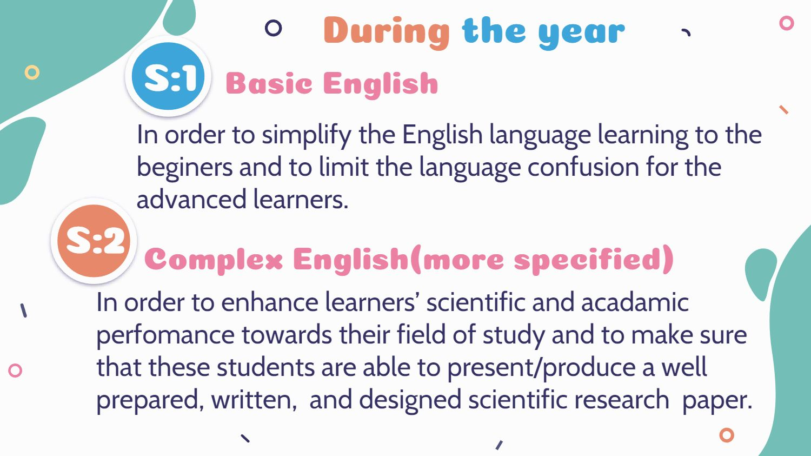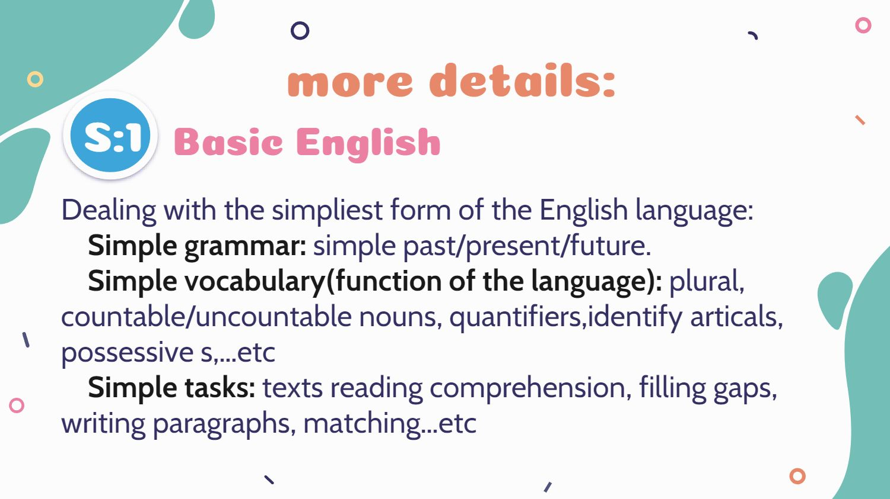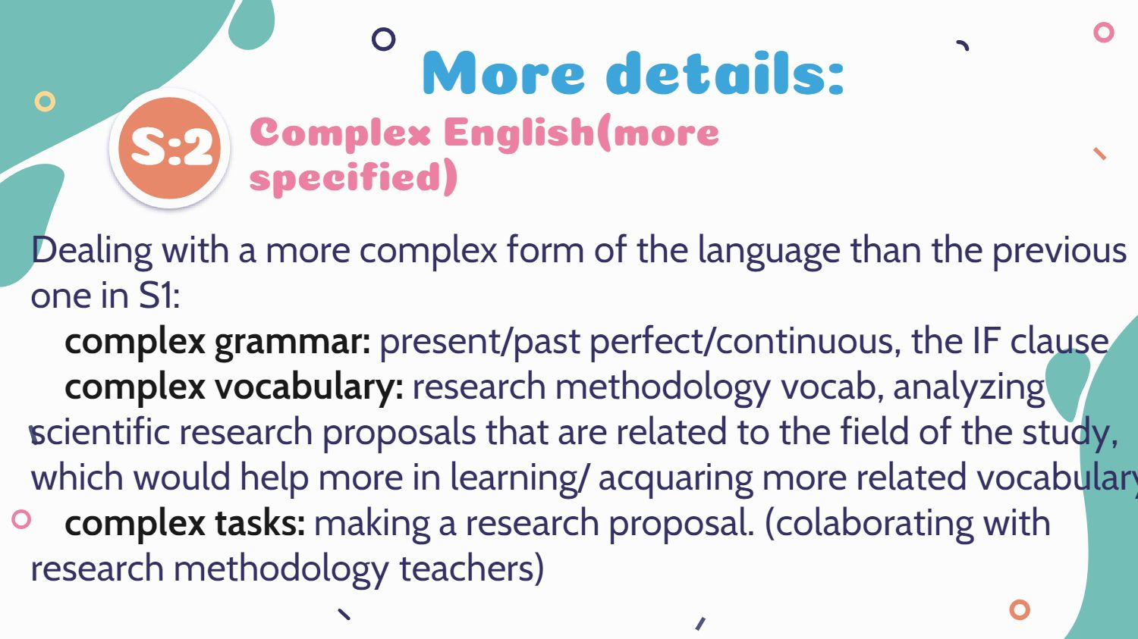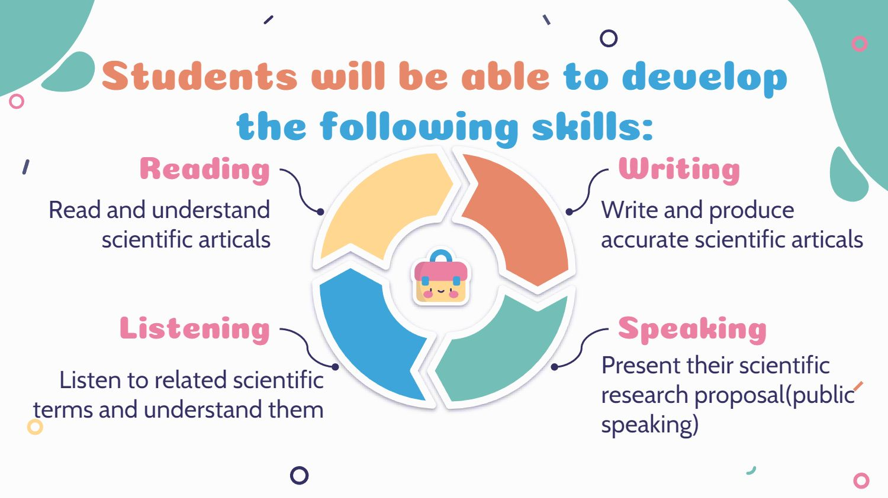

## Discussion Table for Alignments and Misalignments:

|  |  |  |
| --- | --- | --- |
| **Category** | **Misalignments** | **Alignments** |
| Initial Assessment | Lack of formal investigation into students' language situation at the beginning of the course. | - |
| Perception of Proficiency | Discrepancies between teacher's perception and students' self-reported language proficiency levels, particularly in reading and speaking. | - |
| Understanding of Diverse Needs | Teacher's lack of understanding of diverse language needs and uses among Master 1 Computer Science students. | - |
| Syllabus Design | Syllabus design based on classroom observation data, resulting in a course that does not effectively address students' needs and preferences. | Perceived appropriateness of syllabus contents to the level of students, with passages within their reach. |
| Satisfaction & Skill Development | Higher satisfaction with reading and listening aspects of the course, while lower satisfaction was reported for writing and speaking, the skills students reported needing to improve most. | Majority of students finding teachers' feedback helpful in improving their language performance. |
| Teaching Methods | Teaching methods may not be adequately adjusted or diversified according to the specific needs of students in different majors. | Teacher's use of a competency-based approach in designing the ESP course, consistent with the learning-centered approach. |
| Focus on Basic Skills | Heavy focus on basic English skills in the syllabus, which may not be as relevant or useful for Master 1 computer science students with a strong foundation in general English. | - |
| Activity Design | Limited use of collaborative and problem-solving activities throughout the course. | Efforts to use authentic materials and resources, such as Computer Science research proposals and incorporation of ICT tools. |
| Teacher Autonomy | - | Autonomy granted to the teacher in developing course content and support received from fellow ESP teachers. |
| Assessment Methods | - | Traditional written exams as the main assessment procedure, with students generally finding exams to be at an appropriate level of difficulty. |

**Table 2**: Discussion table for alignments and misalignments of the ESP course.

## V. Chandra Sekhar Rao (2017) Syllabus For EST

Proposed syllabus design for Engineering Students:

|  |  |  |  |  |
| --- | --- | --- | --- | --- |
| **Unit** | **Objectives** | **Content** | **Activities** | **Assessment Methods** |
| **Communication skills** | Develop oral and written communication skills | Language functions, vocabulary, grammar, and pronunciation for effective communication in formal and informal situations, group discussions, interviews, and meetings | Role plays, simulations, dialogues, debates, etc. | Oral tests, written tests, peer evaluation, etc. |
| **Technical writing** | Develop skills in writing technical documents | Writing different types of technical documents such as reports, proposals, manuals, and instructions. Appropriate format, style, tone, organization, coherence, cohesion, and accuracy for technical writing. | Analyzing samples of technical writing, writing drafts, revising, and editing drafts, etc. | Written tests, portfolio evaluation, peer feedback, etc. |
| **Presentation skills** | Develop skills in preparing and delivering effective oral presentations | Using appropriate visual aids, body language, voice modulation, and audience awareness for presentation skills. | Watching and analyzing videos of presentations, preparing outlines and slides for presentations, delivering presentations in front of the class or a video camera, etc. | Oral tests, video evaluation, peer feedback, etc. |
| **Project work** | Develop skills in conducting a research project | Appropriate research methods, data collection tools, data analysis techniques, and documentation standards for project work. | Choosing a topic and a research question, reviewing literature, designing a research plan, collecting, and analyzing data, drafting a research report or paper, etc. | Written tests, project report or paper evaluation, oral defense, or presentation of the project results. |

**Table** **3**: Chandra Sekhar Rao’s (2017) Syllabus For EST

# Resume in Arabic

الهدف من هذا البحث هو التحقق من التوافق بين منهج دورة اللغة الإنجليزية لأغراض محددة (ESP) لطلاب علوم الكمبيوتر ماستر 1 في جامعة باتنة 2 واحتياجاتهم اللغوية الخاصة وتوقعاتهم. مع كون اللغة الإنجليزية هي اللغة السائدة في المجالات العلمية والتكنولوجية ، بما في ذلك علوم الكمبيوتر ، فإن وجود دورة ESP فعالة أمر ضروري للطلاب لتطوير المهارات اللغوية اللازمة للتقدم الأكاديمي والمهني. تستخدم هذه الدراسة نهجًا متعدد الأساليب ، يتضمن الاستبيانات والمقابلات ومراجعة المستندات لتحديد احتياجات الطلاب وتفضيلاتهم وتحقيق فهم دقيق لتصميم منهج دورة ESP.

يحلل هذا البحث منهج ESP الحالي بشكل نقدي ، ويقيم توافقه مع احتياجات الطلاب ، ويسلط الضوء على مجالات التحسين المحتملة. تشير النتائج إلى أنه على الرغم من أن الدورة تحتوي على نقاط قوة ، إلا أن هناك مجالات تقصر فيها في تلبية احتياجات الطلاب بسبب عدم وجود تحقيق رسمي في الحالة اللغوية للطلاب.

تقترح هذه الدراسة توصيات لتعزيز فعالية دورة ESP ، يتضمن هذا إجراء تحليل شامل للاحتياجات ، ومراجعة المنهج بما يتماشى مع متطلبات اللغة المهنية والأكاديمية للطلاب ، وتكييف طرق التدريس لاستيعاب الاحتياجات الخاصة الرئيسية ، والاستثمار في بيئة التعلم و التطوير المهني للمعلمين. تهدف التحسينات المقترحة إلى المساهمة في تحقيق نتائج أكاديمية ومهنية أفضل للطلاب، وتصميم المقررات والممارسات التربوية خارج جامعة باتنة 2، والمواءمة مع الأولويات الوطنية الأوسع لدعم الابتكار التكنولوجي، باستخدام تحليل علمي مستنير من منظور علم اللغة التطبيقي.